Google Meet Audio & Video Conferencing
Google Meet provides both audio and video conferencing to those with an albion.edu account. The program can be accessed at meet.google.com from a Chrome browser, or by using the Google Meet app.

Schedule a Meeting
Start/Join a Scheduled Meeting
Start/Join an Unscheduled Meeting

Schedule a Meeting
*To schedule a meeting, a computer or browser/app-based device is required.

Google Meet integrates directly into the Google Calendar, making scheduling on the Albion system easy. Start by logging into your Albion Gmail account, or visiting Google.com and using your Albion Google credentials to log in.
Find and click the 9 boxes icon on the top right of the screen.
Find and click the Google Calendar icon.
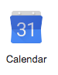
Find and click the desired day and time of the session.

An event pop-up box will appear.

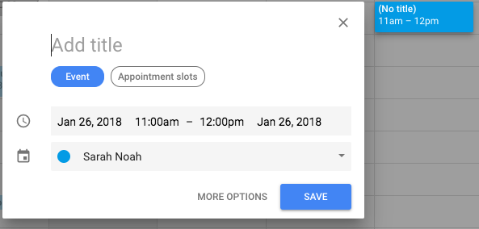

In order to make this appointment an audio or video conference session, click on More Options on the bottom right of the event box.

The next page allows the user to add more event details. Be sure to provide a title and ensure the date and times are correct for the desired session.

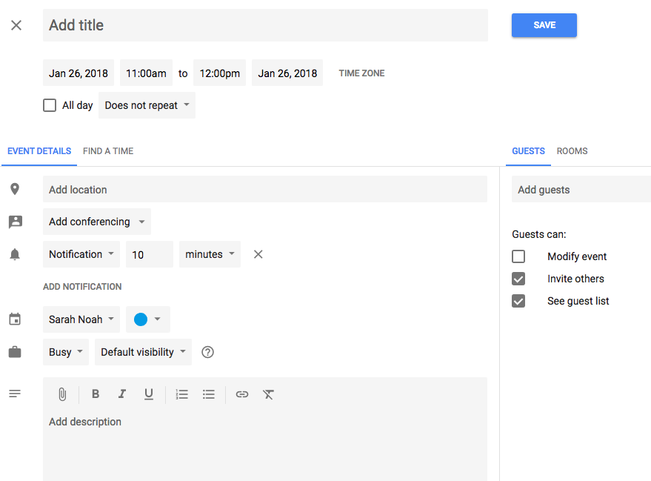

Find and click the Add conferencing drop-down box. Choose Hangouts Meet.

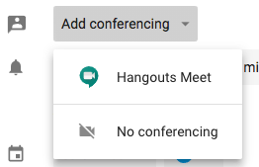

To invite others directly to this calendar event, find the Guests panel along the right of this page. In the Add guests text box type in the email addresses or names of those you would like to invite to the session.

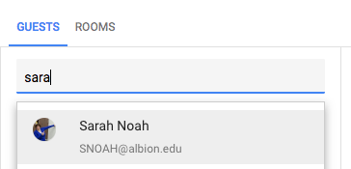

A list of those invited will appear below the Add guests text box. Ensure you have invited all desired guests. Once all desired information is included in the event, find and click Save next to the event title.

Start/Join a Scheduled Meeting

Audio –
Dial the phone number from the calendar invite, or sent through email in regards to the meeting.

When prompted, enter the pin.

Video -

In order to start a scheduled meeting, start by logging into your Albion Gmail account, or visiting Google.com and using your Albion Google credentials to log in.
Find and click the 9 boxes icon on the top right of the screen, then find and click the Google Calendar icon.
Find and click on the desired event. A pop-up with event details will appear.

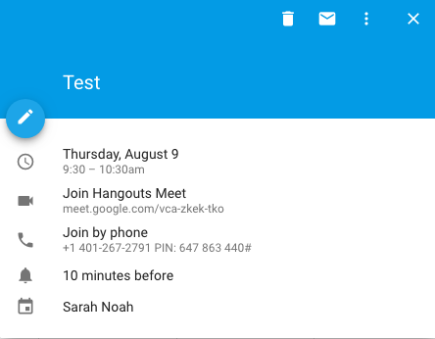

To join using video, find the Join Hangouts Meet link in the pop-up. Click the link to access, or copy/paste the link into a Chrome browser.

To join using audio, find the Join by phone link in the pop-up. If using a phone browser or the Google Calendar app on a phone, click the link to call immediately, or dial the number into a phone and wait until prompted for the pin.

Start/Join an Unscheduled Meeting

Audio –
An unscheduled meeting cannot be started just using audio. A computer or browser-based device is required. In order to create an impromptu meeting, the user will need to follow the instructions for video, keeping in mind they can then connect using a phone once the event is created.

Video -
Start by logging into your Albion Gmail account, or visiting Google.com and using your Albion Google credentials to log in.
Find and click the 9 boxes icon on the top right of the screen, then find and click the Google Meet icon.
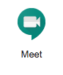

The Meet screen will have options to Start a new meeting, Use a meeting code to join a meeting, or will display any meetings scheduled through the Google calendar. If scheduled through the calendar, simply click on that meeting to launch.

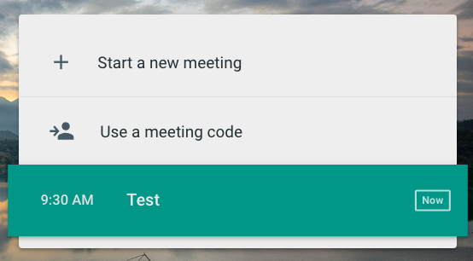

To launch a new meeting, click Start a new meeting.

The next page will show your audio and video settings, as well as the shareable link and phone number for others to join the meeting. Copy/paste the link and send it to those you wish to join the session.

When ready to begin, click Start Meeting.

