Google Meet: Features
Present to a Meeting
Chat
Mute Microphone or Camera
Pin a Screen
Add Someone by Phone
Record a Meeting
Present to a Meeting
*Only available when using video conferencing.

To share a screen during a Google Meet, find and click the Present now button at the bottom right of the browser.

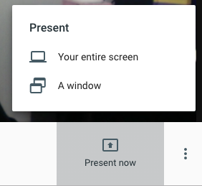

Choose to share either Your entire screen or A window. When clicking on Your entire screen, a pop-up will appear with all your available screens. Click the desired screen and click Share when ready.

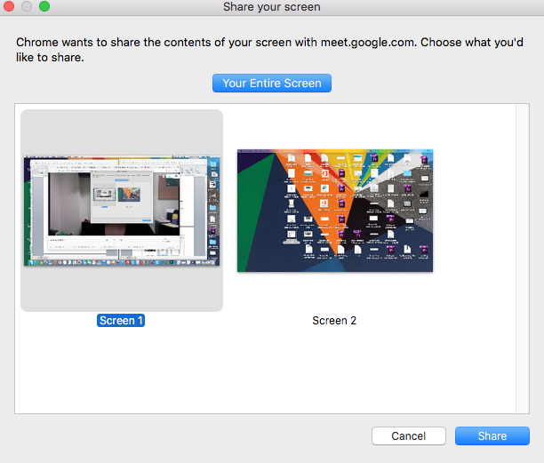
When clicking on A window, a pop-up will appear with all your available windows. Click the desired window and click Share when ready.

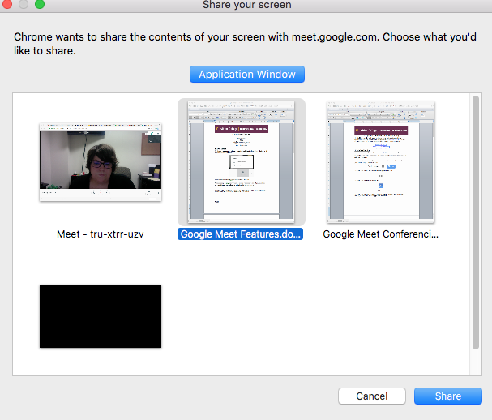

The presenter will see the following screen when they view the Google Meet browser.

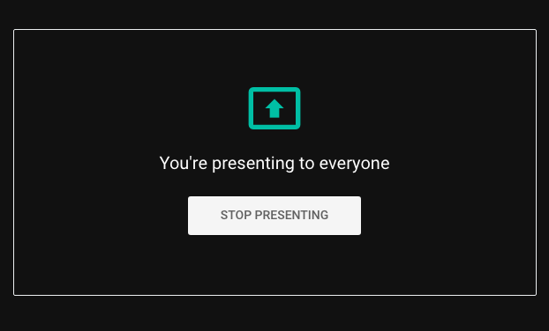

Once clicked out of the Google Meet browser, the presenter will be seeing a normal computer screen, with an added pop-up at the bottom of the screen.

When finished presenting, click Stop Presenting on the pop-up at the bottom of the screen, or click back into the Google Meet browser and click Stop Presenting.

Chat
*Only available to those connected through video.

To use the chat feature, find and click the Chat box tab above the participants list.

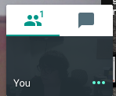

A chat window will appear. Type into the text box at the bottom and click the paper airplane to send a message to everyone in the meeting.

Mute Microphone or Camera
*Only available to those connected through video.

Click on the microphone icon along the bottom of the screen to mute the microphone. Click on the camera icon to block the web camera.

When the icon is filled in with red, the item is muted. To unmute, simply click the icon again. (In the sample below, the microphone has been muted, but the user’s camera is still visible).

To mute the microphones of others, click on their thumbnail image in the participants list.

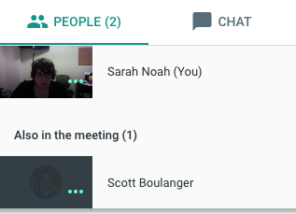

A menu will appear below their thumbnail with several options. Click the microphone option to mute their microphone. Click it again to unmute.

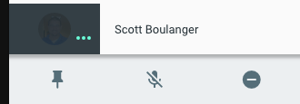
Pin a Screen
When using Google Meet for video conferencing, the active speaker automatically appears as the largest image on the screen. However, sometimes the user may choose to view one person, and does not want the camera to switch to others.

To do this, the user must pin a screen.

Click on the desired users thumbnail image (or screen) from the participants list.

A menu will appear below their thumbnail with several options. Click the pin icon. Click the pin icon again to unpin that user’s screen.

Add Someone by Phone (call out)
To call a phone from an already started video conference, click on Meeting details at the bottom left of the browser.

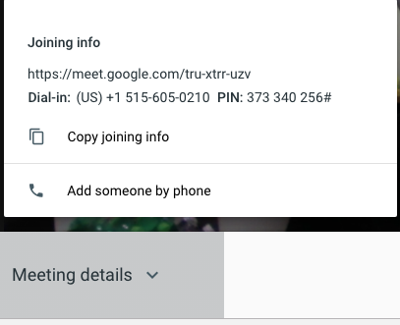

Choose Add someone by phone.

Type in the desired phone number and then click the phone icon on the bottom right.

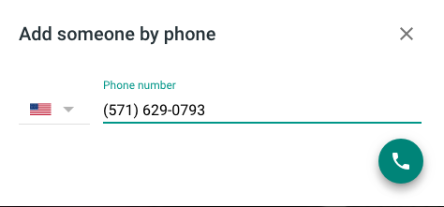

Record a Meeting
*This option is only available if one person in the conference is connected using a computer. If just using audio, the meeting cannot be recorded.

The ability to record a meeting needs to be requested by emailing insttech@albion.edu. If looking to record just once, an Instructional Technologist will schedule the conference for you, making you the owner. If you are looking to frequently record sessions, the Instructional Technologist will work to make this available on your account.

Once permissions have been provided, access the meeting. While in the meeting, find and click the three vertical dots at the bottom right of the window to open another menu. The record option will appear at the top of the menu.

Click Record meeting.

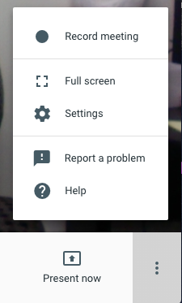

A message will appear to the user and each attendee indicating the meeting is now being recorded.

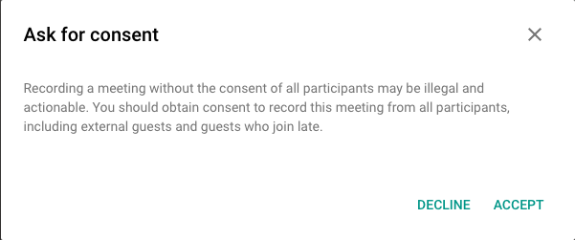

When finished recording, click on the three dots again and choose Stop Recording.

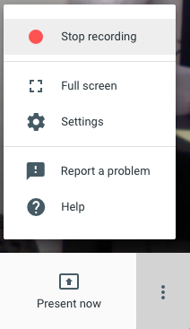

The recording will appear in the original creator’s G Drive. If this is a one-time meeting scheduled by the Instructional Technologist, please email them to request your recording.

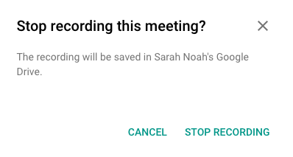

* Any chat messages sent during the meeting will be saved to the Google Drive as a separate document.

