Summer research report to FURSCA summer program and Robson Family Fellows Endowment

**A Study of T7 RNA polymerase - Template interaction utilizing CRISPR/dCas9 protein**

Khulan Enkhbaatar

Advisor: Dr. Christopher Rohlman

**Acknowledgement**

I would like to mention that I am sincerely thankful for Robson Family Fellows Endowment for supporting and funding my research.

**Introduction**

This project is a continuation of FURSCA 2019 summer research. Our primary goal was to explore molecular interaction between dCas9 protein, T7 RNAP and DNA template by using cross-linking method. Transcription is an important cellular process which involves DNA template and T7 RNAP to make RNA. By blocking transcription at certain points, we will be able to study what kind of interaction happens between them. We have chosen the CRISPR/dCas9 system as a blockade in the transcription. Our hypothesis is that he structural interactions between RNAP and dCas9 determine the binding between the DNA template and RNAP. This summer, we planned to do 3D modeling of transcription system to analyze which parts of dCas9 protein, T7 RNA polymerase potentially interact with each other and with U5 DNA template.

Figure 1. The components of in vitro transcription. A. guide RNA will be designed as a complementary to DNA template at specific location(**A**). T7 RNAP is will bind to T7 promoter region at the beginning of U5 DNA template. According to previous research (Widom *et al*., 2019), it showed that T7 RNAP fell off from the template when it encounters dCas9 protein(**B**).

AB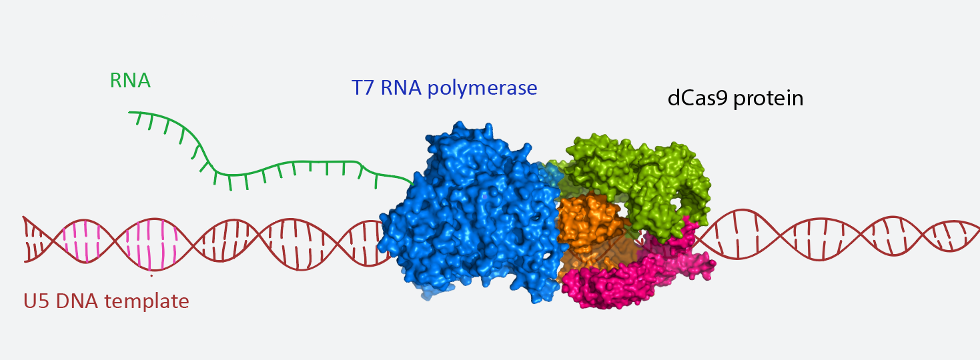

**Results/Summary**

In order to achieve our goal, we have explored and analyzed many different modeling and docking software. Most useful one was PyMOL, which is molecular visualization program. I have completed online Python courses to work more effectively on PyMOL. Before working with PyMOL and other software, we had to have 3D protein or nucleic acid structure of our T7 RNA polymerase and dCas9 protein. There are 13 T7 RNA polymerase (T7 RNAP) and 33 dCas9 protein 3D structure files found from Protein Data Bank website. They are all relatively complete structures, but they differ from each other in terms of what molecules they bind together and what species they are from. In transcription blockade model, components are all dynamic in the aqueous environment, dCas9 protein and DNA templates are relatively stationary comparing to T7 RNAP because T7 RNAP itself is in very active translational and rotational motion along the DNA template. In order to understand how T7 RNAP change its conformation and orientation throughout the transcription process, we have read many papers related to bacterial and phage RNAP translocation mechanism. There were several proposed mechanisms of initiation and elongation of transcription by the T7 RNAP. Although it is known that T7 RNAP is single subunit and relatively small(98kDa) protein, its elongation complex organization is very similar to multi-subunit RNAP. During transition from initiation to elongation complex, N-terminal domain of the T7 RNAP shows most structural change by exposing its hydrophobic surface while C-terminal domain is largely unaltered. As a proposed mechanism, T7 RNAP has 3 conformations: open, semi-open and closed. At each conformation, different subdomains and loops rotate and translocate to orient T7 RNAP and extend RNA product properly. We research deeper into structural changes between 3 conformations to find out most probabilistic orientation and conformations of T7 RNAP for our model when it encounters dCas9 protein.

We designed U5 DNA template 3D structure by using PyMOL nucleic acid builder. Although this model is not dynamic as we expected, it can be used to design preliminary transcription model. We need to explore more advanced tools and learn how to use them to create more realistic and dynamic model. So far, we have found different web-based and desktop-based software tools to analyze possible interactions between these components of the transcription, which can be calculated as most energetically favored and less sterically hindered according certain algorithms of these computational tools. We haven’t finished the model, but we were working on components of the model separately and will be ready to combine them in the future.

**Conclusion**

Originally, we planned to design cross-linking experiments in vitro and optimize the condition to test our hypothesis. However, in order to create more efficient and well-designed experiment, it is essential to have deeper understanding about the possible interactions between our molecules. This summer, reading many great papers, working with visualization software and thinking about possible ways to solve many unanswered questions we had helped me to improve myself as a researcher and realize how throughput and step-by-step process a research itself is. If our hypothesis is right and we can hopefully understand interactions between these components at molecular level, this work can help to create an efficient, reversible dCas9-mediated transcription control mechanism. Because transcription itself is the first step of gene regulation, which is responsible for gene expression, cell functions and traits. I plan to continue my research this fall through directed study with Dr. Rohlman and start writing my thesis for this project.

**Reference:**

Widom, J. R., Rai, V., Rohlman, C. E., & Walter, N. G. **2019**. Versatile transcription control based on reversible dCas9 binding. *RNA (New York, N.Y.)*, *25*(11), 1457–1469.