Sustainability at Albion College
Greenhouse gas inventory and a cost-effective renewable energy model
Introduction
Global greenhouse gas (GHG) emissions have significantly increased since the 1900s. In 2014, United States contributed to 15% of the total global carbon dioxide (CO2) emissions from fossil fuels [1]. With emission levels at its highest, there is an immediate call to reduce global emissions to net zero. Academic institutions particularly are in a well-placed situation to take on a leadership role in fighting climate change due to their unique role in educating future generations of leaders. This responsibility extends to the institution’s own GHG emission reductions, energy and water conservation, and other sustainability initiatives.
The first step towards taking action, is measuring our impact. This can be done via a GHG inventory. A GHG inventory is a widely accepted tool used to track and report emissions of the six GHG covered under the Kyoto Protocol: carbon dioxide (CO2), methane (CH4), nitrous oxide (N2O), hydrofluorocarbons (HFCs), chlorofluorocarbons (CFCs) and sulphur hexafluoride (SF6) [2]. A GHG inventory acts as a tool to help policy makers develop strategies and policies for emission reductions and to track the progress of those policies. The inventory will also promote actions based on data recorded following the results.
Electricity in particular is one of the GHG sources and accounts for 27% of total GHG emitted by the United States [1]. If Albion College wants become carbon neutral, we have to invest in renewable energy. We can either buy renewable energy certificates (RECs), set up a power purchase agreement or have on-campus renewable energy production. This summer I planned to create a comprehensive greenhouse gas inventory and also set up a cost-effective renewable energy model for the College. I had further planned on making recommendations to the College based on my findings.
Results/Summary
We created a simple model that calculated a cost-effective solution to transition towards renewable energy for Albion College. Using linear integer programming we found that if the College were to have 25% of our electricity from renewable sources, then the net present costs for the next 20 years would be 3,292,190$. For this, we would need fifteen 50kW photovoltaic (PV) system and twelve 100kW wind turbines. Since our model is dependent on various parameter values, we assume the following values given below in Table 1.1. Our results can also be seen visually in Figure 1.1. Here the gradient of net present costs is shown, with red representing a higher cost, and blue a lower cost. The x and y axes represent the number of PV panels and wind turbines respectively. Point A shows the optimal solution within our shaded constraint region.
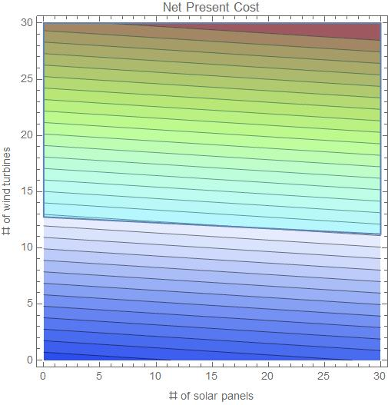
Figure 1. Net present costs for renewable energy system under the given shaded constraint region.
This model is a great starting point, but there are multiple avenues for improvement. Some of my future work will include considering other system costs such as batteries and converters, using more accurate energy equations and, incorporating other financing options such as loans. True projections also require statistical analysis with error and uncertainty. I hope to further work on this after taking more math classes in the next few semesters.
We also collected electricity consumption, natural gas use and population data for the last three fiscal years. Due to COVID-19, data collection was more difficult than anticipated and we weren’t able to collect all data needed for a greenhouse gas inventory. While working with Facilities, I also found multiple outdated systems that was adding to the delay in data collection. This problem was brought up, and we are now working together to create an electronic system that will make data collection easier and faster in the future. I also created a guide to creating an inventory for Albion College, which will be submitted along with the EOSR. The guide will help students/staff throughout the inventory process by introducing basic terms and helping them identify the right resources on campus.
Conclusions
We created a good model to make preliminary analysis on the cost of renewable energy for Albion College. We also collected data for major greenhouse gas sources. There are multiple avenues for improvement that I hope to work on in the future. Through my FURSCA project, I was also appointed the Presidential Sustainability Coordinator. I am now working with professors, staff and students to create a sustainability action plan for Albion College. This includes planning towards carbon neutrality, creating a sustainability committee, and working with Facilities and Accounting office to set up a system to easily measure our greenhouse gas emissions.
Through my FURSCA project, I gained extensive knowledge in accounting and data collection for greenhouse gas inventories. I was also introduced to renewable energy markets and became more comfortable with linear integer programming. This project also opened new leadership opportunities within campus. I plan to continue working next summer and also present my findings at Elkin Isaac Symposium in Spring 2021.
Table 1.1. Parameter values used in the model for example.
Parameter | Value
PV system | 50 kW
Wind turbines | 100 kW
Capital costs – solar/PV | 50,000 $ for 50kW PV system
OM costs – solar/PV | 1000 $/panel/year
Capital costs – wind turbine | 500,000 $/turbine
OM costs – wind turbine | 40,000$/turbine/year
Electricity price from the grid | 0.1 $
Total electricity consumed by the College | 16,388,581 kW
r (rate of interest) | 5%

References
[1] EPA. (2019). Global Greenhouse Gas Emissions Data. Retrieved on July 31, 2020, from
https://www.epa.gov/ghgemissions/global-greenhouse-gas-emissions-data#Trends .
[2] WRI. (2018). Greenhouse Gas Protocol. Available online at
https://ghgprotocol.org/sites/default/files/standards/ghg-protocol-revised.pdf.

