Courtney Lamrouex
My summer research for FURSCA was titled Academic and Athletic Identities of Division III student athletes. I assisted Dr. Scott Melzer in his research to find out how Division III student athletes identify themselves: a student, an athlete, both or something else. We wanted to know what it is like being a Division III student athlete, how these student athletes identify and what their level of commitment was to both athletics and academics. We wanted to complete this research because there is very little research that has been done on Division III student-athletes, a population that does not receive athletic scholarships yet invests nearly as much time and energy into their sports. We wanted to compare and contrast this to Division I student-athletes where research reveals their athletic identities shape their sense of self. While preliminary research on Division III student-athletes suggests they have more of a balance between their academic and athletic identities. Overall, this summer research helps our understanding of how Division III student-athletes balance their athletics and academics, which could also be used to improve their athletic and academic experiences.
My FURSCA experience was a bit different than other student researchers. The full story is: Dr. Melzer is conducting a broad study on D3 student-athletes and athletics, focusing on small, private D3s where S-As are at least 10% of the student body which is about 300 private colleges. The project began when he did an Albion College pilot study last Fall, surveying and interviewing current and former student-athletes with the help of nine student research assistants. insights and findings from the pilot research led to his revising the questionnaire and interview guides for the national study. Originally, Dr. Melzer anticipated collecting lots of interview and survey data last semester so my research partner and I could spend much of FURSCA coding and analyzing it. Alas, covid hit and I delayed data collection, focusing instead on already available institutional data on the colleges in the dataset. Summer hits, students' lives begin to settle down a bit, we start FURSCA... then we delayed soliciting interview participants again out of respect for the rising BLM movement, after George Floyd was killed in late May. So we pivoted from our original plans twice, and we have been doing many different tasks to help push the project forward in other ways like literature review, coding interviews and searching for interview participants. Still, as planned we did Grounded Theory Method training. This method is the collection and analysis of data. The theory is “grounded” in actual data, which means the analysis of theories happens after data has been collected. The primary purpose of this method is to develop a theory or theories about our collected data. After FURSCA is over Dr. Melzer will continue data collection for his larger project which will eventually turn into a book.The research we have done this summer is all still in progress and Dr. Melzer will continue to develop it over time. I attached an image below of an interview that was conducted during FURSCA and how we would code these interview answers. The coding is used to help develop themes throughout the interview and throughout various interviews.

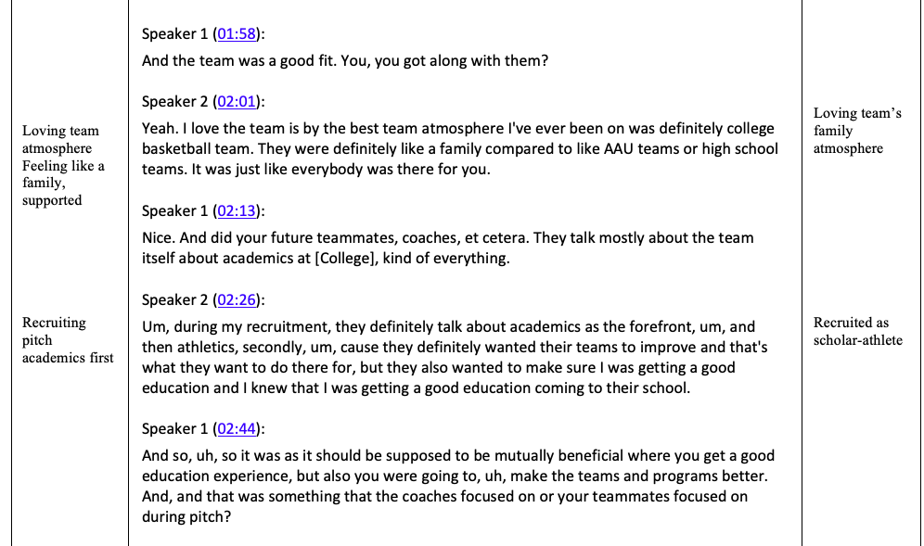

Our research found that overall, Division III student athletes find time to be dedicated to both athletics and academics fairly evenly. They feel like they are given opportunities to succeed in academics as well and in general reported feeling very supported by professors and their family while being really close with their teammates. The former student athletes though reported feeling not very satisfied with their experience.
Some of our interviewees demonstrate these findings well in some statements they made. With our finding that student athletes in Division III feel like they are satisfied with their academic experiences and in general feel like they are given opportunities to succeed in academics, an interviewee had this to say: “I'm putting my time into my sport I love but at the same time I love putting in as much for academics. I told my dad, I am going into college and university because of my academics and softball always be there for whenever I need it whenever I have time to enjoy it and do it.” An interview had this to say about student athletes feeling very supported by professors and their family and they were really close with their teammates “Our professors really do care about your wellbeing and your life and everything outside of it. Which helps in the long run with your education and what we want to do. So yeah, we're really close with our professors and, they have good, good, good teachers.” Unfortunately, the former student athletes feel not very satisfied with their experience. But, this is important to know for our research so we can see different reasons why student athletes are no longer involved in their sport. An interview said: “I didn't have the greatest experience there. I kind of like, I'd gone downhill a little bit. It just, I don't know. I felt like I had to like fight all the time for something that I'm just like, that I've worked hard for it, but I had to fight people for which those people didn't really work that hard for it”
This research was important to me because I also am a Division III student athlete and have many friends who are also Division III student athletes. I wanted to know how our hard work compares to those who attend Division I schools even though we do not receive athletic aid like they do. I was also interested in knowing how much time and dedication Division III student athletes have to our academics since the majority of our financial aid is academic based. I was also able to improve my qualitative research skills and had the chance to learn sampling strategies and processes, interviewing, coding data, and how to think about data on different analytical levels. Dr. Melzer plans on taking the research we did this summer, developing it more and turning it into a book while my research partner, Clare and I present at Elkin Isaac in 2021.

I wanted to dearly thank the Hyde Fellows in Student/Faculty Research Fund because my research this summer would not have been possible without the support of this fund. This research helped me learn immensely about student athletes and I enjoyed my time completing it.

