Introduction
My project is called Casino Euchre. It centers around the idea of turning euchre into a casino game. This project was a continuation of my research from last summer where I️ researched what made a good casino game and how those ideas could be applied to euchre. The rules of euchre were adapted to fit the model of a successful casino game. Then the main goal was to create a strategy. This was the main goal of this summer’s research along with completing the computer program from FURSCA 2019 and looking into the idea of a user interface for the game.

Summary
I️ started my summer with my program from last summer. I ended the last FURSCA with a fully functioning program and started this FURSCA with a program with a program that did not work at all. I️ spent the first chunk of my research trying to get my program working again. This was a problem I️ did not expect to encounter and set me back in my plans for the summer. I went through the entire program and re-familiarize myself, adding comments that explained what everything did for the program. In hindsight I️ should have done all those comments last summer, so I️ didn’t end up having to read my code like it was a riddle given to me by a troll under a bridge. I️ EVENTUALLY found the problem through a lot of googling and consulting a computer scientist. I️ fixed the problem in my code after many tears of frustration. I️ then went through the code and streamlined it. It was previously chunky and was held together through prayers and sheer willpower. I️ reorganized things and made it a little more nice to look at. It still is clunky but it is as good as I️ can make it with my limited coding knowledge.

Next I created some art for my research. I️ had been planning on making a felt design since last summer and finally made it. It is designed for four people to play against the dealer. A maximum of five players can be played but then all of the cards are in use, which is more susceptible for card counting. I️ designed the logo with all of the Jacks in the deck. I️ chose the Jacks because those are the highest cards when they are trumps. I️ used a color scheme that is similar to a lot of popular casino games. The rankings are also visible on the felt for player clarication.

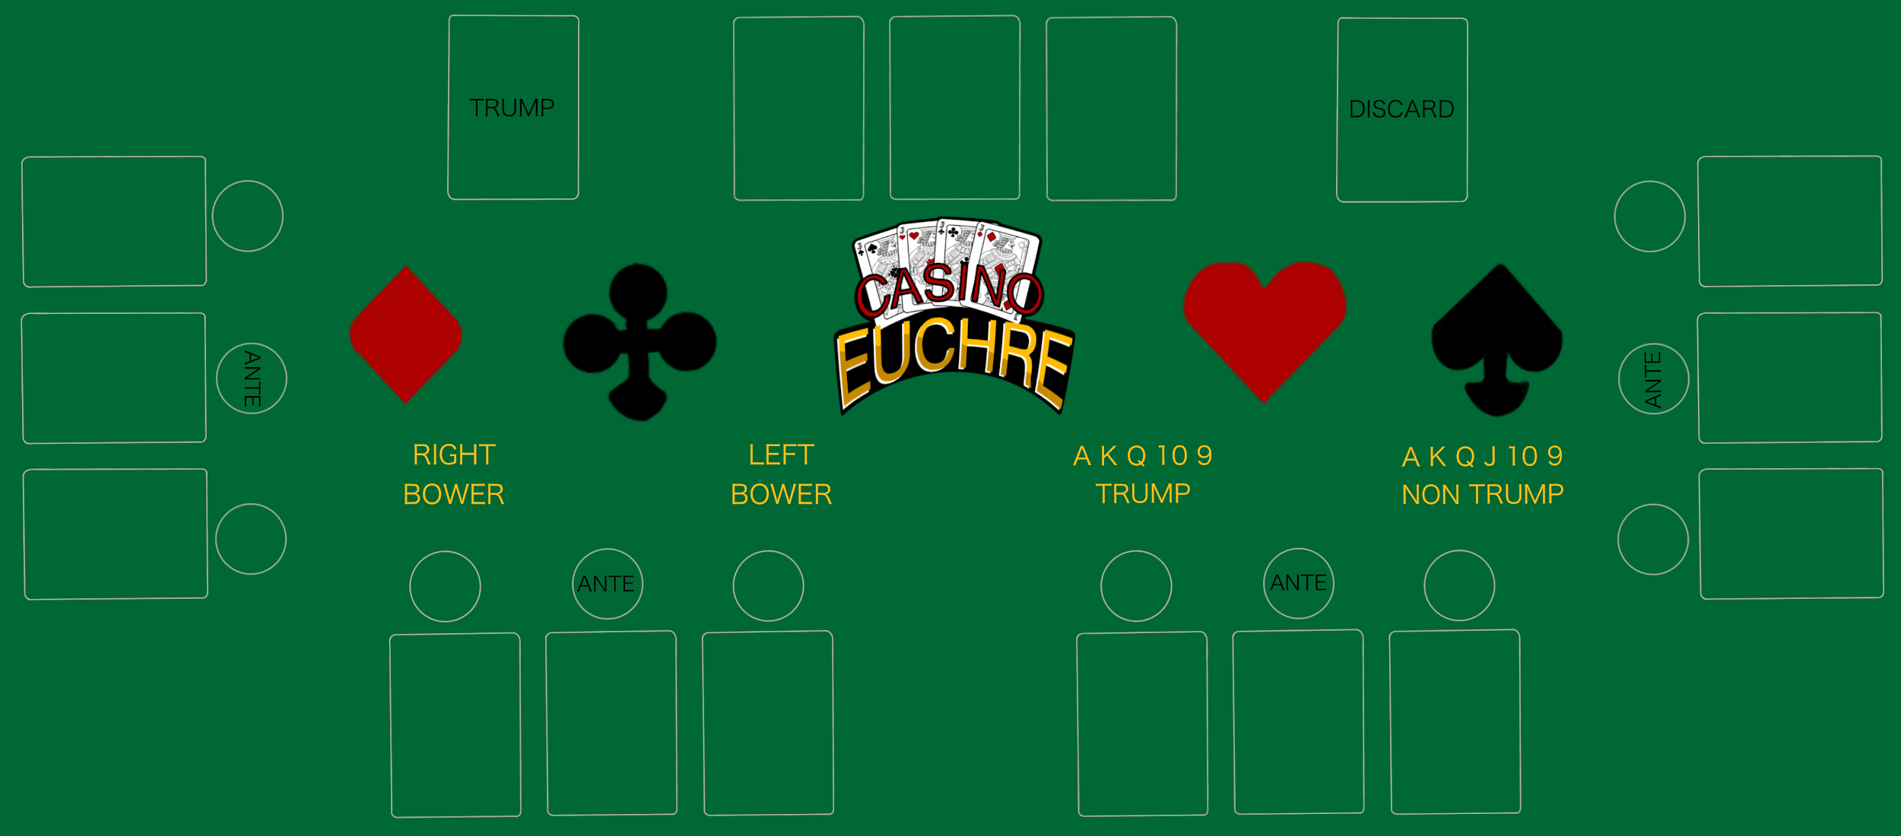
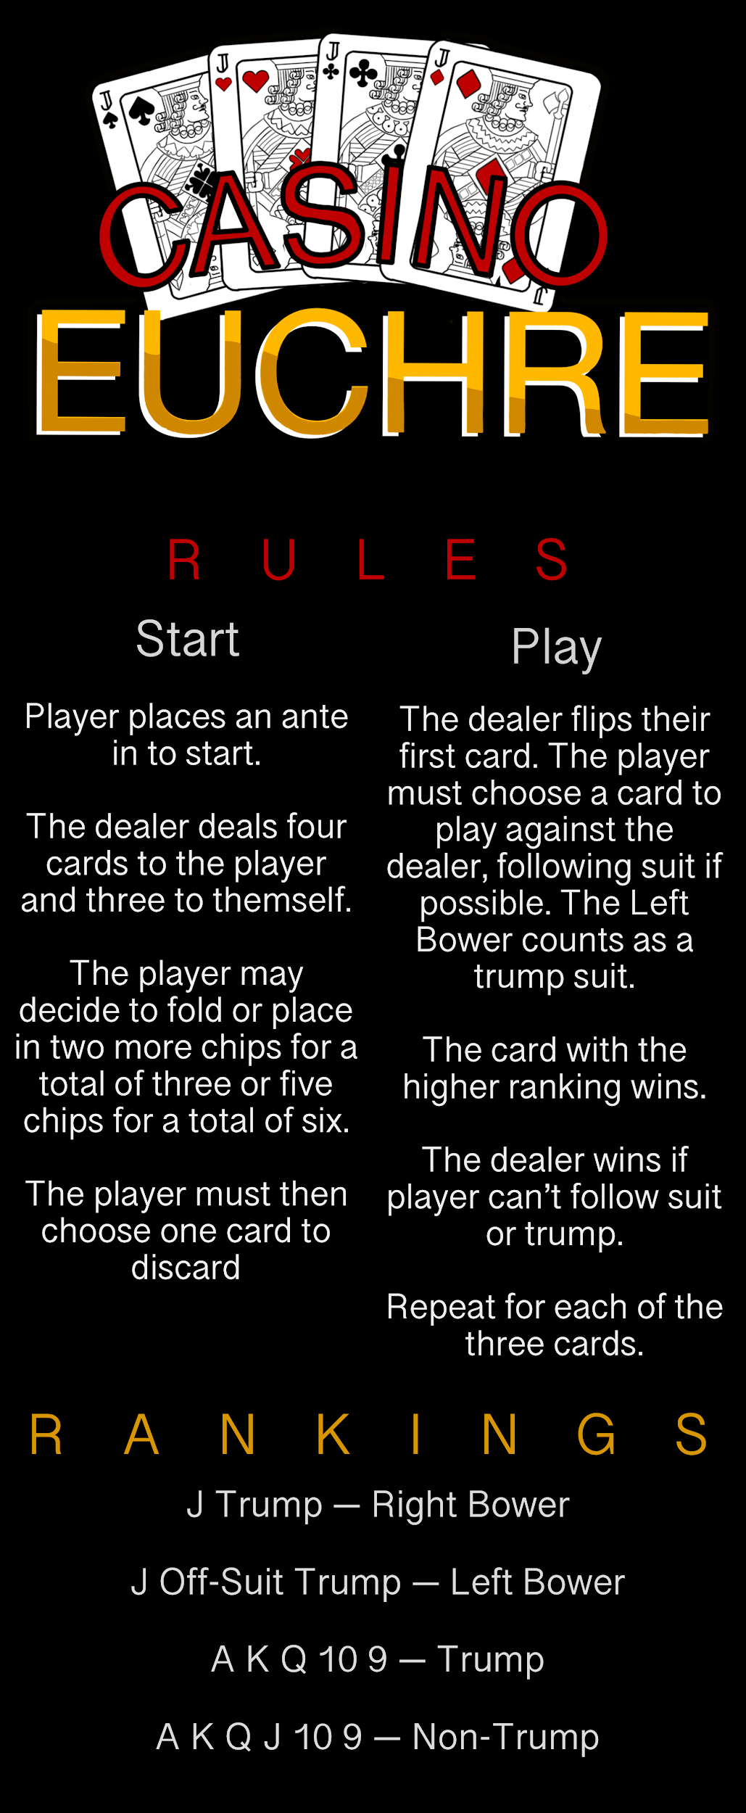
I️ also created a rack card. This is the card that would be displayed in informational racks. It contains a condensed version of the rules for the game.

I️ love art and digital art is a new hobby of mine, so it was really fun to be able to combine this project which is very technical with something a little more creative.

Post art, I️ went back to my coding. I️ wanted to play as many hands as possible to see if the strategy was holding up or if I️ needed to tweak it. I️ recorded the hands in terms of high medium and low cards and how many tricks were won in the hand. I then tabulated that data in a table that contained every possible combination of high low medium and trump cards.
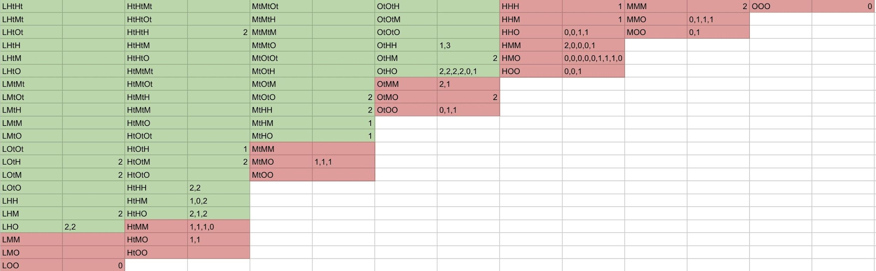
Not every hand was obtained, but after awhile I️ saw a general pattern. I️ wanted something clear that I️ could put into the program. I️ decided that every hand that had a trump and a high card should be played and everything else should be folded. I️ programmed this into the code. I️ wasn’t necessarily happy with this though. I️ was still curious about the hands with three high cards of non trumps. So I decided to create another program that allowed me to dictate the player's hand and run a ton of dealer hands at the singular player's hand and record the number of wins and losses. This program was crude and by my best efforts seems to work. Three non trump aces were tested as the player's hand. This proved to be a lucrative hand. Next three non-Trump Kings were tested. This was not a lucrative hand. I️ also tested AAK and this also proved to be a disappointing hand. This was an interesting result as the cutoff was not quite where I️ anticipated it to be. This change in strategy is reflected in the program.

I️ also wanted to try and create a user interface that allowed the player to play in a way that simulated the look of a real game. This proved aggressively challenging, this was a task way beyond my coding capabilities, but I tried for a long time to figure it out. I️ got to the point where I️ created a user interface that shuffled a deck of cards and dealt theme back and forth for all of eternity. This was as far as I️ got. I️ ran out of time and was not able to take this to a further state to create a user interface for the game. The game is still able to be completely played via my program; it is just through words and not images. Below is the output of the program created.
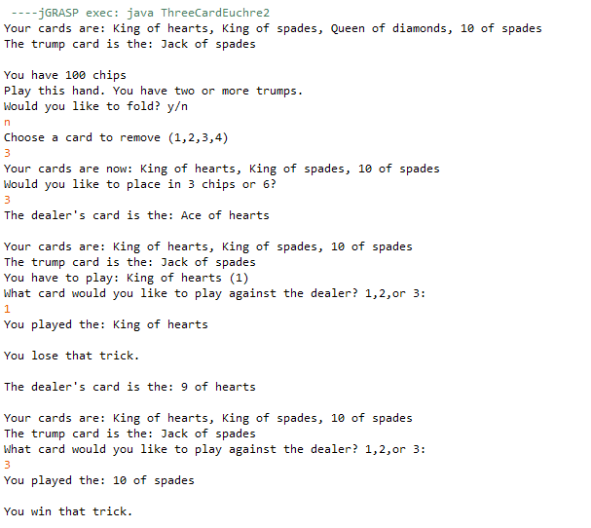
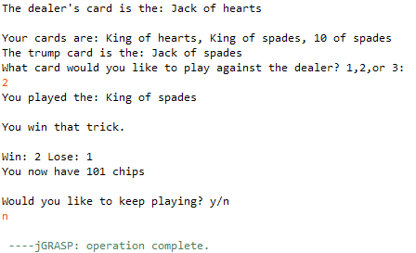

Conclusion

I️ plan to share my research at Elkin Isaac in Spring of 2021 (if it is allowed to happen). I️ am also using my research to write my senior Honors thesis. This project taught me a lot about computer programming, patience, and problem solving. Going into this project in Summer 2019, I️ had taken CS 171 and that was it. My experience was limited, and while it does show in the crudeness in my program I️ also grew a lot and transformed it into something that I️ am very proud of. This project is important because it shows the intersections of fields in a fun and inviting way. It shows how math, computer science, and art all go into making something that millions of people enjoy.

Thank you to Bruce A., '53 and Peggy Kresge, '53 Endowed Science Fellows Fund for providing me with the funding to continue my research. This research has helped me grow as a mathematician, computer scientist, and person.

