CJ Morton
8/7/2020
FURSCA EOSR

During this brief summer project I was trying to find a multitude of primers that were polymorphic and could be amplified. I was trying to do this by using stricter protocols than what Cornell labs used for our purposes. The goal was to have a list of primers ready to be ordered so that research could be done right away when the school year started. We have to continue

My goals for this project were achieved over the two weeks I was doing the research. During the two weeks I had the different types of problems I was looking to avoid such as hairpins explained to me by professor Lyons and reinforced by papers I had read. The results of the data I input looked like the following photo. 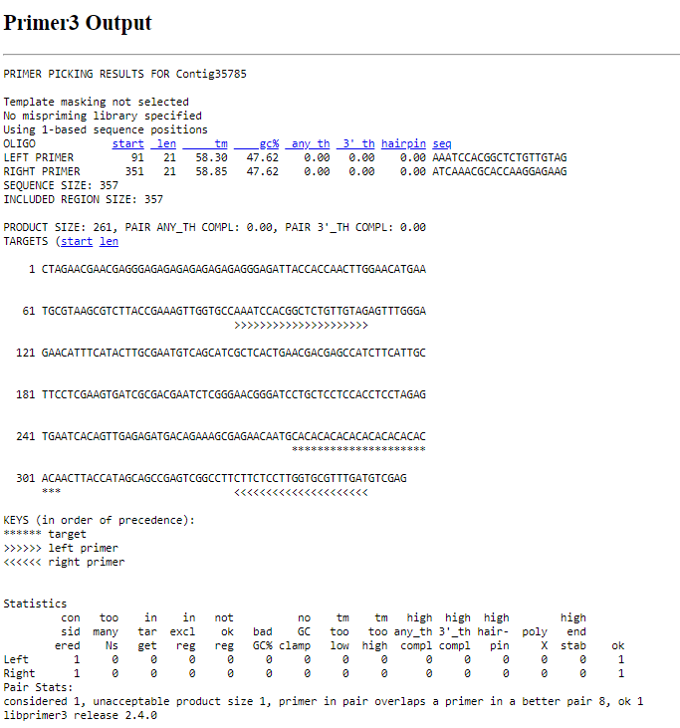
After this result was attained I would record down the information needed in order to buy the primer if it passed through all the criteria. I found that around 30% of the primers i tested could pass through the stringent protocols.

C. Conclusions i. Importance of the project to your future at Albion College and beyond ii. Dissemination plans (thesis, Elkin Isaac, etc.) iii. How did this experience make a difference in your life?

This project was important to my future outside of Albion College because it helped me to further narrow down the type of work I would look forward to doing later in life. I plan on doing a presentation on this research and related research that I will be partaking in during the school year at Elkin Isaac, and maybe elsewhere if the research unearths interesting findings that would be acceptable to present elsewhere. This experience helped me to make it through the monotony of the corona virus quarantine and further showed me that I can work for hours a day at a desk without too much of a problem which was surprising to me. This has helped to shape the future I am trying to plan out.

