Rachel Stander
August 2019
End of Summer Report – FURSCA, Summer 2019

Introduction
The title of my FURSCA project is Sodium Chloride’s Pollution and Deicer Alternatives’ Effects on Aquatic Life in Freshwater Environments. The purpose of this project is to examine road salt’s effects on freshwater systems and the organisms that live in them. The idea for this project prospered while I was conducting research through the Student Research Partners Program with my biology advisor, Dr. Abigail Cahill. As a biology major, I am especially interested in survival and reproduction in various environments. Humans have contributed to the toxicity of many environments, which has produced detrimental ecological impacts. For my summer FURSCA, I examined how road salt administration in our freshwater environments has affected survival and species richness of its inhabitants.
Every winter, many cities in the Midwest, especially in Michigan get pounded with the annual headache of snow and ice. Most cities and townships send out salt trucks to decrease the hazard for drivers and pedestrians. These trucks administer the chemical compound sodium chloride, or NaCl on roads and sidewalks. NaCl is a solution to de-icing the roads because it lowers the freezing temperature of water, which accelerates the melting process of street-clogging snow and ice. Once this chemical reaction occurs, sodium and chloride
ions in the water drains into the sewers, soil, and other freshwater river systems throughout Michigan, which will inevitably come in contact with the existing aquatic life. This is an inexpensive and quick-acting solution to melting ice. However, it contaminates the groundwater, soil, rivers, and lakes in Michigan’s freshwater system. This salt contamination of the freshwater harms the aquatic life. Aquatic plants and animals are dying due to the salt pollution in their habitats. Road salt deposition has proved to produce ecological drawbacks in Michigan’s freshwater.
This environmental issue has led me to my proposal for FURSCA research. The goal of my research was to experiment with possible alternatives to NaCl, which still manage to melt the ice but cause less of an impact on the freshwater organisms. Alternatives I used in my experiment included Beet-It Ice Melt, pickle juice, sugarcane molasses, and sand, which I exposed to common freshwater organisms. Another goal of my experiment was to test a variety of NaCl concentrations on freshwater organisms and measure their survival and reproduction. The goal was to try to find a concentration threshold which still melts the ice but without the detrimental impact on the organisms.
Overall, this experiment and research was targeted at trying to find the safest way to solve the icy roads dilemma without harming our environment or speeding up the oncoming next mass extinction.

Methods and Results
My FURSCA project was separated into two experiments. Both examined how freshwater organisms react to foreign substances but were focused on different questions.

Experiment I.
In my first experiment, I tested a variety of alternatives to road salt on four common freshwater organisms in Michigan. The goal of this experiment was to establish an alternative solution to NaCl without causing the ecological impacts that NaCl produces. The design of this experiment included exposing four organisms to six treatments. These treatments consisted of NaCl, Beet-It Ice Melt, pickle juice, sugarcane molasses, sand and a control of spring water from Victory Park in Albion, MI. A 20 mL concentration of each of the six treatments was poured into a glass shot glass with four replicates for each treatment. Then I extracted and placed the organisms in the shot glasses. The organisms include Eisenia foetida (earthworms), midge larvae, and species of zooplankton which included ostracods and Daphnia pulex. Unlike the other organisms, the earthworms were placed in deli containers with soil, which were similar to their natural environment. Once exposed to the treatments, I collected data daily on survival, mortality and reproduction of the organisms, as well as feeding them daily.

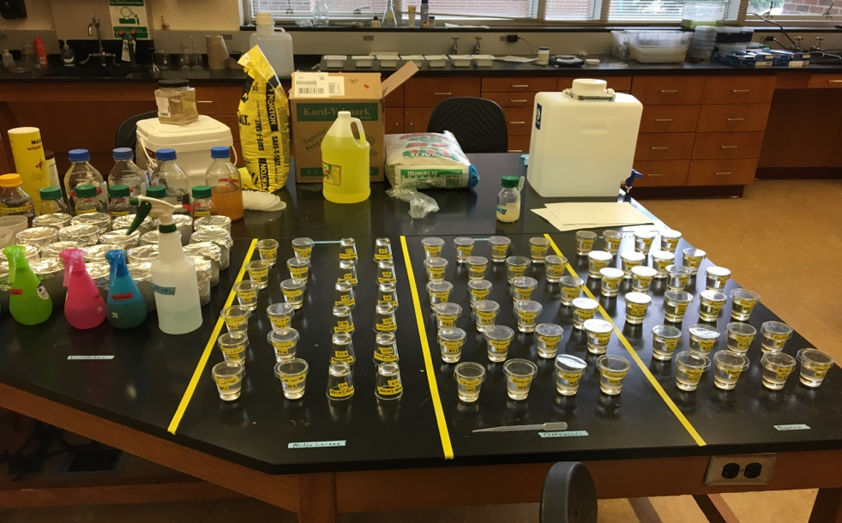
Figure 1. The setup of the complete experiment. The organisms are divided into quadrants.
The collected data for the first experiment was analyzed using ANOVA. The graphs below demonstrate the statistically significant results and are separated based on organism.

Daphnia pulex.
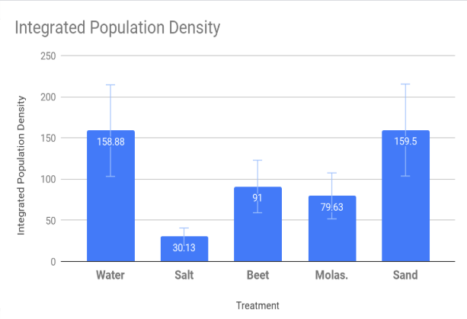 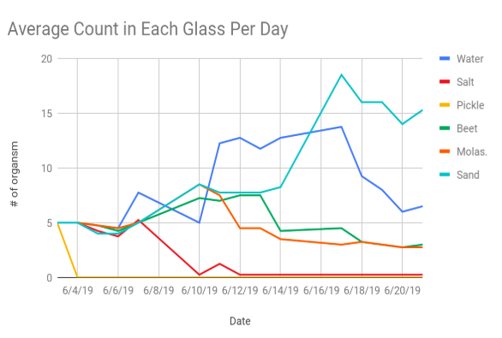Figure 2,3. Water and salt are significantly different. Sand and salt are significantly different. P-value: 0.006. Collected data was analyzed using ANOVA and the trapezoid rule was used to calculate the integrated population density.
Ostracod.
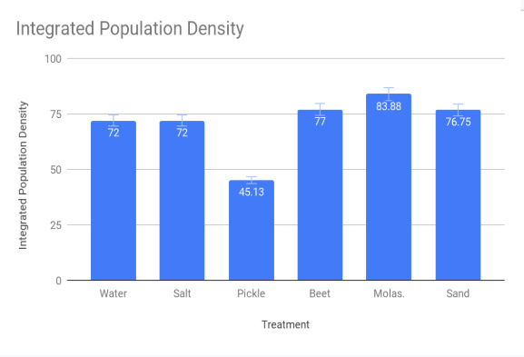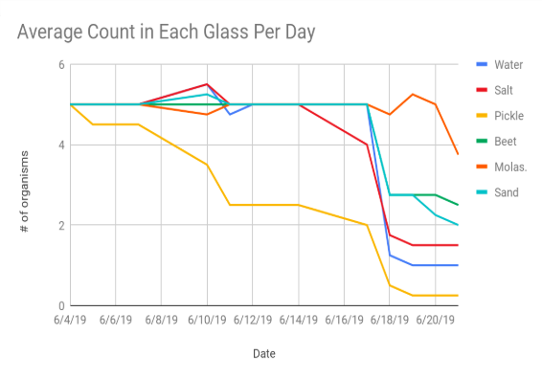
Figure 4,5. Pickle is significantly different with all other alternatives. P-value: <.001. Collected data was analyzed using ANOVA and the trapezoid rule was used to calculate the integrated population density.

Eisenia foetida.
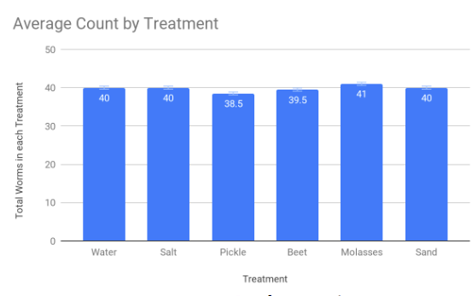
Figure 6. No significant difference between treatments. P-value: 0.142. Analysis of variance was used to evaluate data.

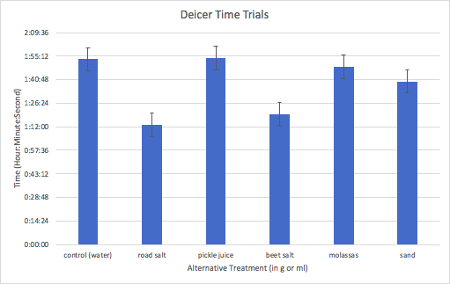
Figure 7. Exposed each treatment to ice and recorded the time it took to melt it. The road salt and beet salt melted the ice the quickest.
Experiment II.
In my second experiment, I set up a similar layout to my first experiment except I tested NaCl concentrations on the organisms instead of alternatives. I created five NaCl concentrations which were mixed with spring water. These concentrations included 0.1 g/L, 0.5 g/L, 2.5 g/L, 5 g/L, and 10 g/L. They ranged from a very low salt concentration to a very high salt concentration. I exposed each of the organisms to the concentrations in the same method as the alternatives. This experiment was almost identical to the first experiment except for the treatments. I collected data on each organism’s survival and reproduction daily as well. The goal of this experiment was to establish a NaCl threshold in which freshwater organisms aren’t detrimentally affected by the salt, but it still has its ice melting abilities. The graphs below demonstrate the results from my second experiment.

Daphnia pulex.
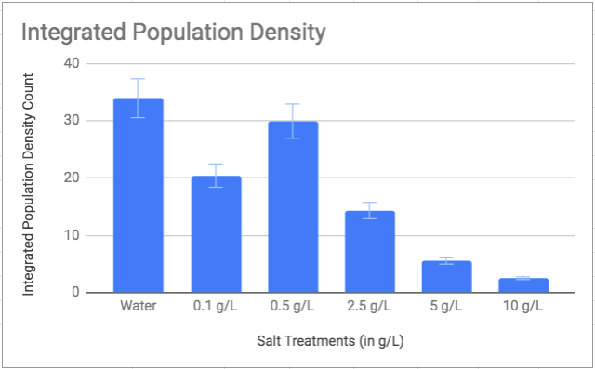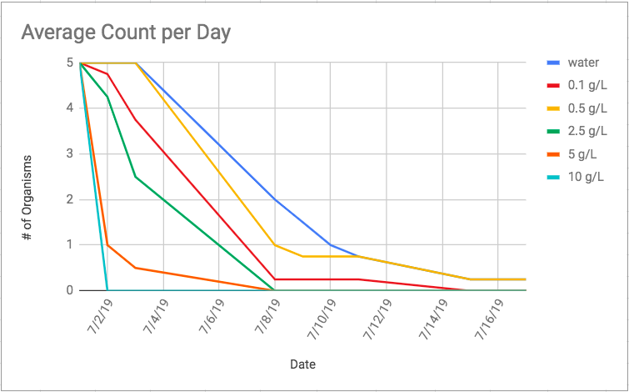
Figure 8,9. The results show that most of the Daphnia died in all concentrations.

Ostracod.
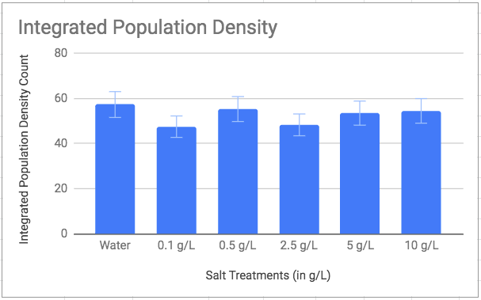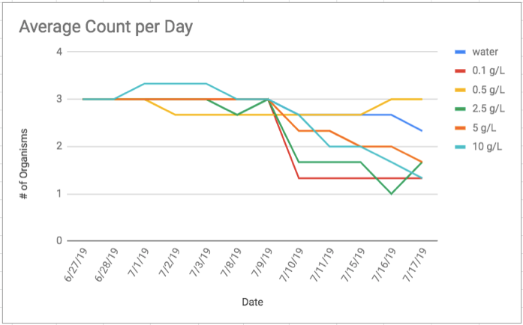
Figure 10,11. The results show that the ostracods survived equally as well in all the NaCl concentrations.

Eisenia foetida.
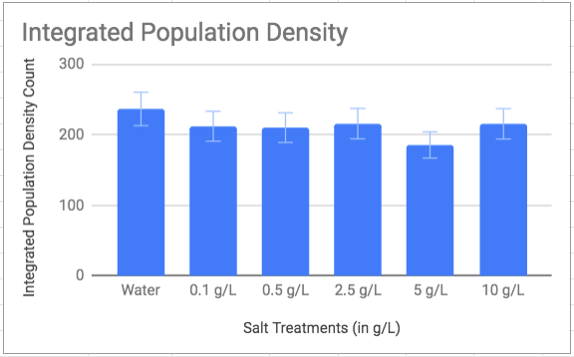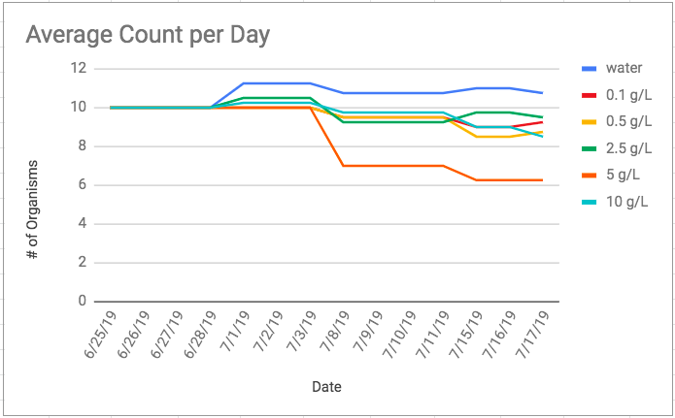
Figure 12,13. The earthworms survived the best in the lower NaCl concentrations as opposed to the higher concentrations.

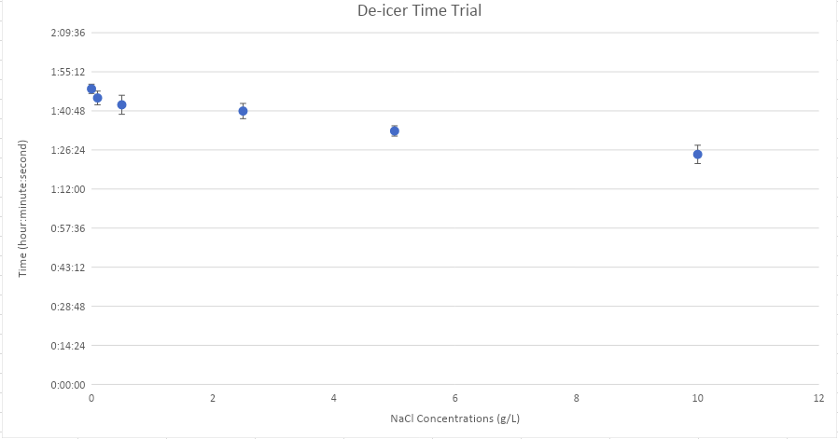
Figure 14. Exposed each NaCl concentration to ice and recorded the time it took to melt it. The higher the salt concentration, the quicker the ice melted.

Conclusions
The results of my first experiment demonstrate that there is not one answer to the solution of administering a harm-free deicer alternative. Each organism which I experimented with thrived and died in different alternatives. The Daphnia thrived in the sand, but all nearly died in salt. Ostracods had the highest survival in molasses and beet. Worms survived in all treatments, partly due to living in soil which contained less concentrated salt. Midge Larvae
appeared to die in everything (too small of sample size to provide graphs and include in results). In conclusion, there is not a specific road salt alternative that I’ve experimented with that solves both the icy roads issue as well as not producing harmful ecological impacts to the water systems.
The results of my second experiment are relatively similar to my first experiment as well. There is not one NaCl concentration that all freshwater organisms are unaffected by. In the Daphnia’s case, road salt is incredibly toxic and completely kills all the organisms, regardless of the concentration. Ostracods don’t appear to be as affected by the NaCl in any concentration that I tested. The midge larvae’s sample size was once again too small for significant data, but they also completely perished in all the concentrations. Lastly, the earthworms did demonstrate higher survival and reproduction rates in the lower concentrations. In conclusion of the second experiment, the lower the salt concentration, the better for the environment and organisms.
My next steps are to finish calculating the data and evaluating the statistical significance of the results from the second experiment of my FURSCA project. I plan to present this research at biology conferences and at the Elkin R. Isaac Research Symposium in Spring 2020. Also, I plan to base and write my senior Honors thesis on this and similar research.
Overall, this was an incredible experience in which I learned an immense amount of information, procedures, and personal interests. This experience has helped and inspired me to continue conducting research after I finish my undergrad and continue onto graduate school.

Endowed Funds – Thank You!
I am incredibly thankful and appreciative of the donors who provided me with endowed funds through the FURSCA program to conduct this research. I would like to personally thank Bruce A., '53 and Peggy Kresge, '53 and the Endowed Science Fellows for their generous donation which helped fund my project. They are who allowed me to expand my knowledge and appreciation in this field of study. Thank you!

