Psychoplastogens are a relatively new class of drugs that have been proposed to increase neural plasticity in the brain. Neural plasticity is the brain’s ability to re-wire its neural circuits to help create alterations in thinking patterns and looking at life in a new ways. In order to study this, drosophila Melanogaster was used to study the effects of 2,5-Dimethoxy-4-iodoamphetamine (DOI), a psychoplastogen. Four different types of mutant flies were used to study the differences in locomotion to determine if the DOI worked better for a specific mutant. In order to study the effects of the drug, locomotion assays were ran to obtain data about improvements or declines in locomotion. Since the nervous system and muscular system are closely intertwined there was a presumption that if there was an increase in locomotion, there would also be an increase in neural circuitry. Based on past studies it has been shown psychoplastogens have the potential to treat PTSD (post-traumatic stress disorder), depression, Huntington’s disease, Alzheimer’s disease, and Parkinson’s disease. The goal was to analyze the effects of DOI to see if it could increase the locomotion of a mutant.

In my first week of running locomotion assays a lot of the work was getting each mutants baseline locomotion ability. In order to do this, I put the flies in a clear tube, tapped them all down, then gave them 20 seconds to climb up the tube towards the light, the natural instinct for d. Melanogaster. After analyzing multiple assays and running an Enova analysis, the data suggests that there was an increase in locomotion for the HTT mutation (Huntington’s disease). Also, within those assays it was found that the wildtype flies, no mutation or DOI given, did not have a decrease in locomotion throughout the process. The other three mutations did not have a significant correlation, so it was decided to focus the remaining time on the HTT mutation and running a positive control on the wildtype flies. Below is the data collected from the first week showing the data collected from the HTT mutation.
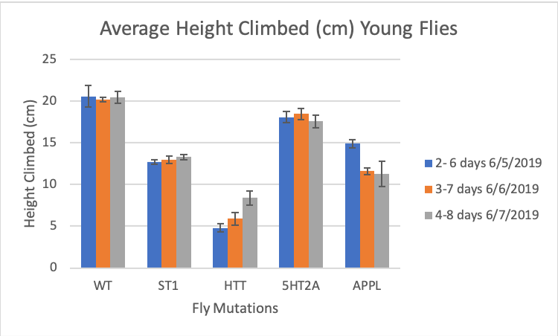
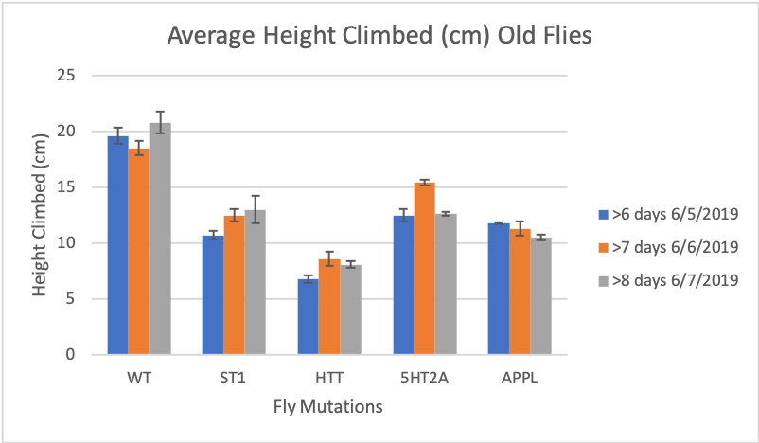

During the second week of collecting data it was found that when wildtype flies are dosed with 40 µg/mL of DOI there is a significant decrease in locomotion showing that DOI could possibly have a cytotoxic effect on the fly. In addition, I ran a control group on the HTT mutant and also ran an assay with a higher dosage of DOI (200 µg/mL) and it was found that at a high dosage of DOI there was no significant increase in locomotion.

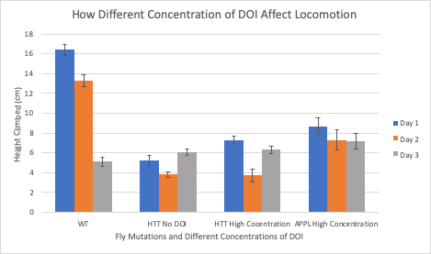

Some future directions this project may go are to run more locomotion assays on the HTT mutation with different dosages of DOI. Due to time constraints we were only able to run the DOI in a high dosage and unable to do a lower dosage such as 10 µg/mL. Another possible direction that is worth studying is giving a one-time dosage of DOI then studying how long DOI approximately stays in the system of the flies. Finally, one last direction that was brought up was feeding DOI to the flies as larvae then running the locomotion assays as adult flies.

This experience as a freshman undergraduate student has helped shape my undergraduate career in research, introducing to the methods and thought processes of how research should properly be conducted. I plan on using this experience to continue my research career in a different subject, such as cellular biology. This project would not have been possible without the help of Orpha Leiter Irwin Fellowship. I would like to thank them for allowing me to expand my horizons in research while studying as a pre-medical student.

