End of Summer Report

- Introduction:
For this summer, my FURSCA research is about the Diversity and distribution of marine cryptic species. Cryptic or sibling species are different species that are often impossible to differentiate based solely on physical look. Cryptic species are ecologically and evolutionally important and understanding them can help us make effective conservational measures.
My research consisted of 2 main phases. In the first phase, I performed multiple analyses for marine cryptic species using data from existing databases. My goal was to understand their distribution, habitats, composition, and diversity in different oceans (Pacific, Atlantic, Indian, Southern, and Arctic). In the second phase, I analyzed the gene sequences of 2 species: moon jellyfish (Aurelia aurita) and sunfish (Mola Mola).
My goal was to identify different cryptic species within those species.

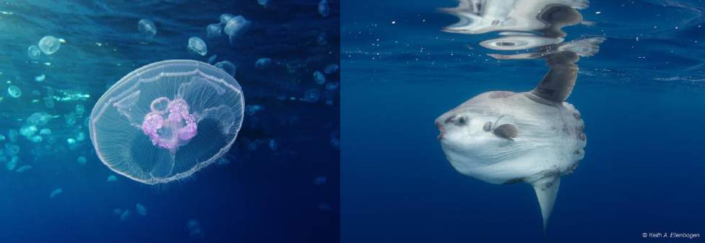
Aurelia aurita Mola mola

- Results:
For the first phase of the research, I was able to accomplish my goals and got some results about the diversity and richness of cryptic species in different oceans. Here are some interesting results I found. First, I found that the values of Expected and Observed richness (the number of different species) of cryptic species are different in all oceans. The Pacific has the highest cryptic species richness while the Southern Ocean has the lowest richness.

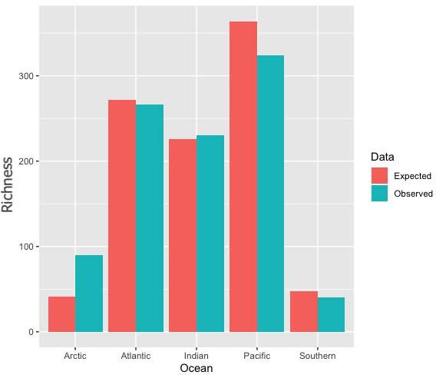
The Expected and Observed richness of cryptic species in different Oceans The expected richness follows the pattern made by previous researchers (there are more described species in the Pacific, and fewer in polar regions), so it gives more credibility to the comparisons being made. Based on chi-squared tests, observed
richness of cryptic species in the Arctic Ocean is significantly higher than expected and the Pacific Ocean is significantly lower than expected. These differences can be explained by the sampling efforts differences in Oceans (the sampling efforts are not consistent across Oceans) and some phyla in specific Oceans are more likely to have cryptic species.
Second, I calculated the beta diversity (how different the smaller regions are within one area) in Oceans over regions of 1000 miles apart.

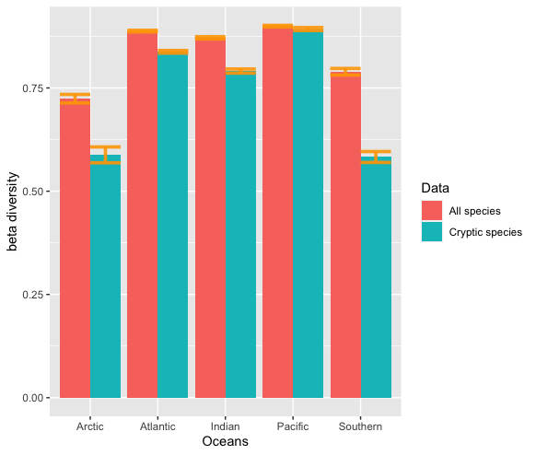
Beta diversity of all species and just cryptic species in different Oceans
I found that the Beta diversity of all species and cryptic species only are different except in the Pacific Ocean. This result may be explained by the various habitat ranges (islands, coral reefs) in the Pacific making cryptic species widespread and evenly distributed in this ocean.
For the second phase of my research, I was facing a few technical challenges at first. I had a hard time learning to use the code to extract DNA sequences and process those sequences to make phylogenetic trees. I was struggling because this part of the research was more coding-heavy. Through the challenges, I learned to troubleshoot and I also finished what I set out to do. First, the results from gene analysis of the moon jellyfish suggest that cryptic species are present within the species. I looked at 2 different genes: COI-5P and ITS1. The analysis of the COI gene in the jellyfish doesn’t show any clear genetic divergent patterns. However, the phylogenetic tree from the ITS1 gene shows divergent groups of jellyfish. The genetic distances of groups suggest that there can be at least 4 different cryptic species within the moon jellyfish.
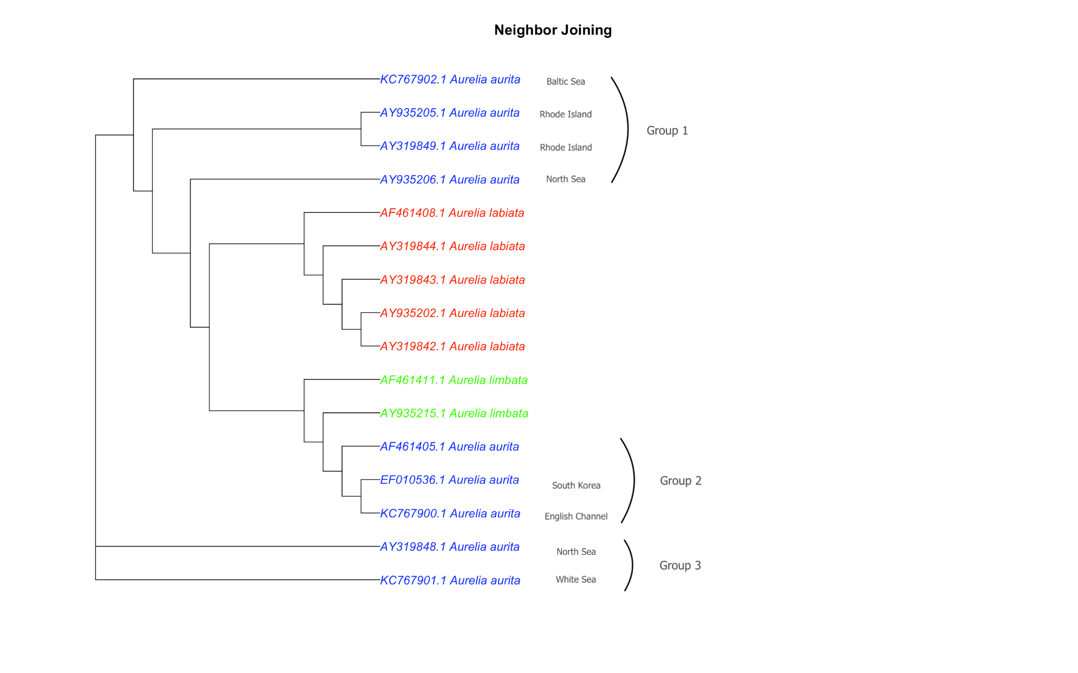
Phylogenetic tree based on the ITS1 gene of moon jellyfish

These groups of Aurelia aurita are genetically different from each other regarding the ITS1 gene. They are found in different habitats and parts of the world. This result matches the results that have been found in previous research(Dawson MN and Jacobs DK, 2001). Second, I perform genetic analysis of the sunfish with the COI-5P and D-loop genes. The COI gene pattern with the gene distances suggests that there can be at least 4 different unidentified cryptic species within Mola mola.
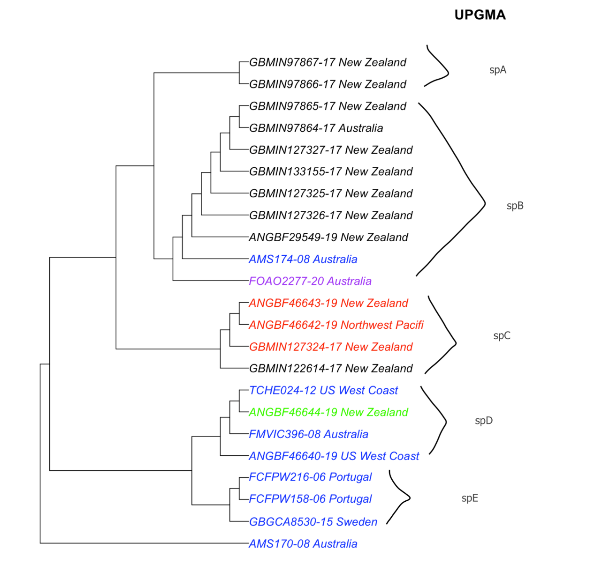
Phylogenetic tree based on the COI gene of sunfish
Sunfish are discovered to have long migrations across the oceans, so it can explain how animals of each cryptic species are sometimes found far from each other. For example, in species D, the sunfish are found on the US West Coast as well as in Australia and New Zealand. My Dloop gene analysis is based on the research of Yukiko Yoshita et al. (2009). In that research, the authors divided the sunfish samples they collected into groups A and B in which Group A found mostly on the Pacific coast of eastern Japan, while group B was widely distributed along the Kuroshio Current. D-loop gene analysis suggests that there can be at least three different species of Sunfish within these two groups.
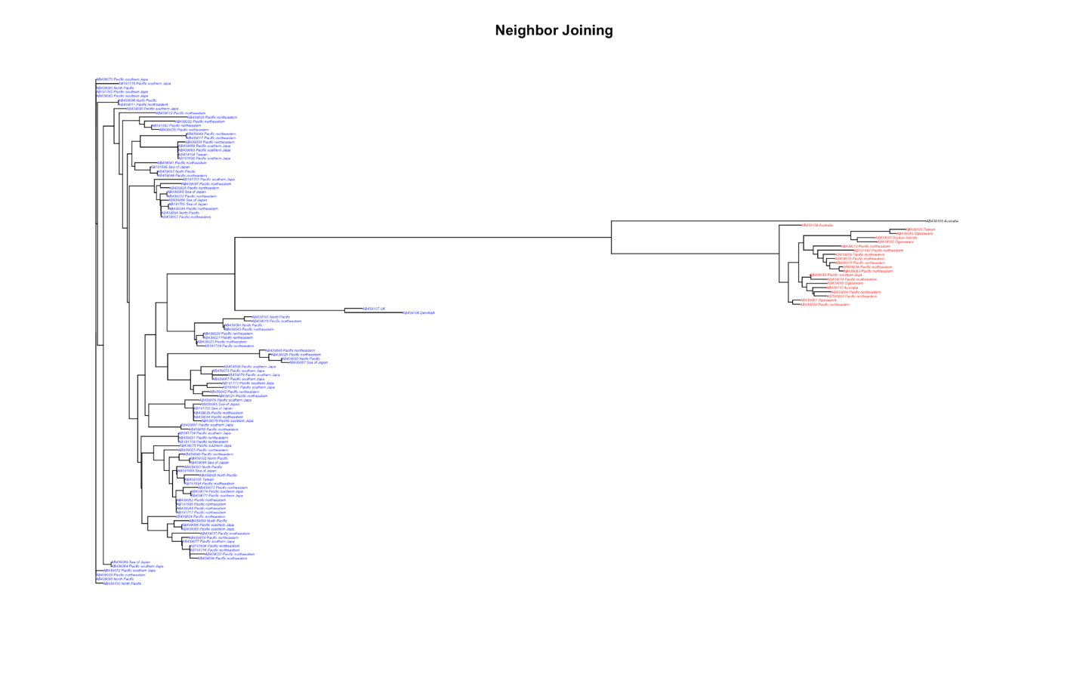
Phylogenetic tree based on the D-loop gene of sunfish

C. Conclusions
I find this research a great opportunity for me to develop my research skills and get hands-on experience in programming as well as biology. These experiences are helpful to me as a Biology major and applied Math minor as they allowed me to apply what I have learned to do useful research. This research lines up with my future career as a biologist. Throughout the seven-week work, I learned to troubleshoot and practice my coding skills. I also learned how to deal with big databases and how to manage files. Sometimes, I got overwhelmed and stressed out but as I overcoming it, I got to know how to deal with problems and to work efficiently. This experience with FURSCA summer research is meaningful to me as it helps me understand and clarify my future career directions. Before working on FURSCA research, I was somewhat unsure about my future goal but after getting practice, I decided to pursue a career as a biology research scientist. I’m really grateful and would like to thank all the donors, FURSCA committee members, and my advisors for making this happen.
My research will be presented at the next convenient Elkin Isaac Symposium and potentially at an off-campus meeting such as the Society for Integrative & Comparative Biology or the Evolution meeting. It will hopefully be published with the related work on cryptic species that Dr. Cahill is conducting with her collaborator Dr. Anne Chenuil.

CITATION:
- Dawson MN, Jacobs DK. Molecular evidence for cryptic species of Aurelia aurita (Cnidaria, Scyphozoa). Biol Bull. 2001 Feb;200(1):92-6. doi: 10.2307/1543089. PMID: 11249217.
- Yoshita, Y., Yamanoue, Y., Sagara, K. et al. Phylogenetic relationship of two Mola sunfishes (Tetraodontiformes: Molidae) occurring around the coast of Japan, with notes on their geographical distribution and morphological characteristics. Ichthyol Res 56, 232 (2009).

