Mary Beall
Summer 2019

End of Summer Report:
Electrochemical Reduction using Metallic Nanoparticle Carbon Microsphere Composites

This summer I worked with metallic nanoparticle carbon microsphere composites to use as catalysts in place of commercial alternatives. Platinum disks are widely used in electrochemistry, a branch of chemistry that uses electrical currents to promote a reaction. However, despite being one of the best metals for electrochemistry, platinum is a very expensive metal due to its low concentration in the Earth’s crust, meaning an alternative to a platinum disk electrode using either less platinum or different metals is desirable. The oxygen reduction reaction and peroxide reduction reaction are widely studied using platinum disk electrodes.¹ This makes these reactions helpful to use to study alternative catalysts with. Previously, platinum nanoparticle carbon microspheres were used to coat glassy carbon electrodes to reduce oxygen to water.² These are an improvement from the platinum disk electrode because they use a much smaller amount of platinum, lowering the cost to run these reactions. This summer I made platinum nanoparticle carbon microspheres to use on glassy carbon electrodes to reduce oxygen and peroxide to water as an alternative to platinum disk electrodes.
During the first few weeks of FURSCA this summer, my concentration was on synthesizing platinum nanoparticle carbon microspheres. To make these microspheres, I used ultrasonic spray pyrolysis. This consists of a diffusor with a precursor solution that is nebulized and fed into a furnace, evaporating water and leaving solid particles with carbon, platinum, and potassium chloride. After the furnace, the particles are carried by nitrogen gas into two bubblers where the salt dissolves, leaving porous carbon microspheres with platinum nanoparticles embedded within them. The synthesis of these microspheres was successful since they have been made in Dr. Metz’s lab previously, including by myself last summer.² Also while in Albion, I was reading literature pertaining to electrochemistry to prepare for running my own electrochemical experiments.
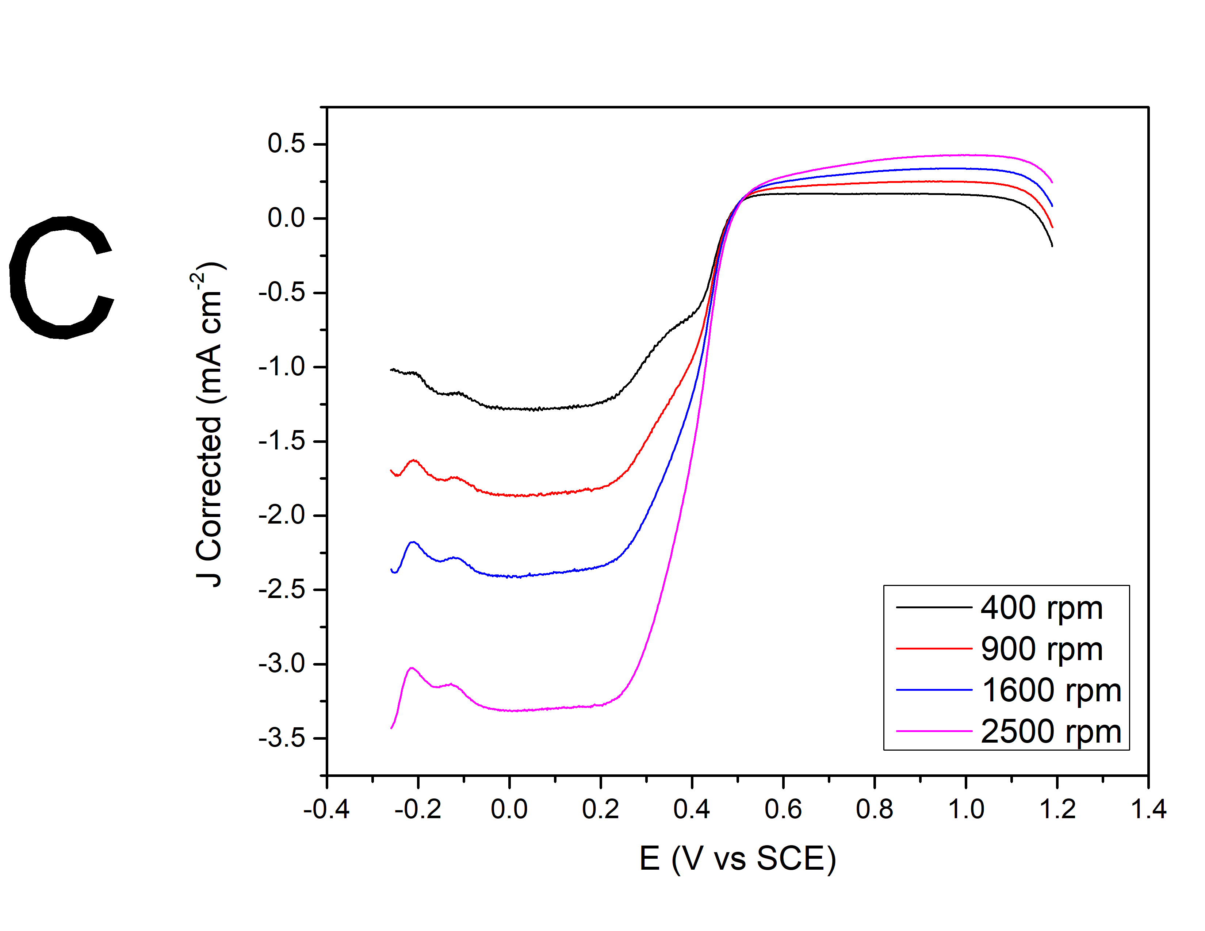
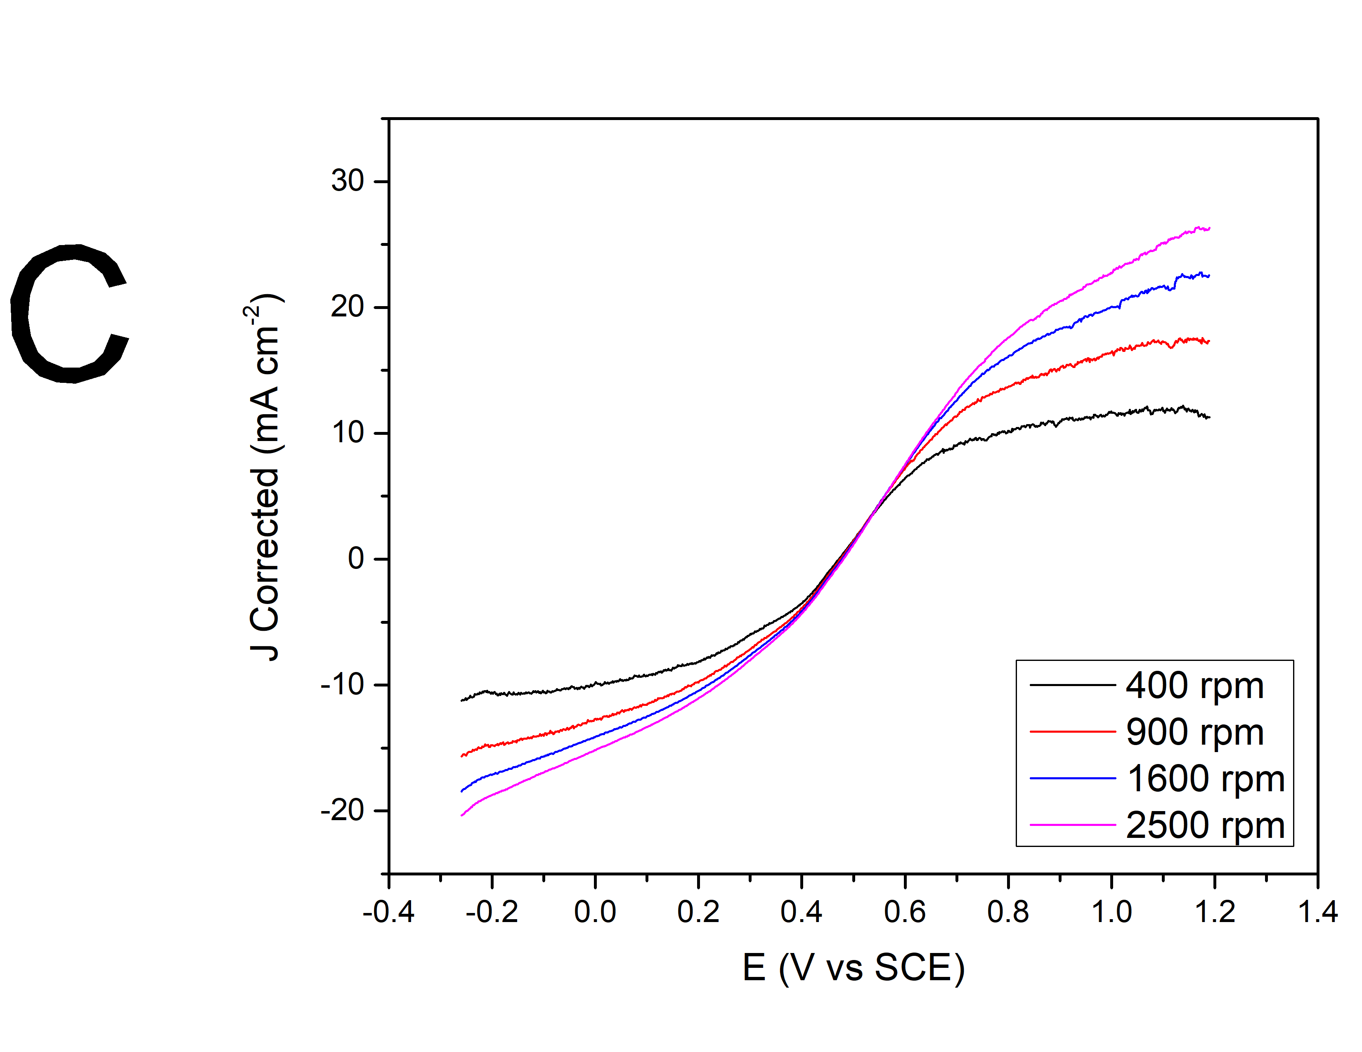
About halfway through the summer, I was able to travel to Trinity College Dublin in Ireland to continue working on this project in a lab run by Dr. Paula Colavita. Here, the focus was on using platinum-carbon composites as catalysts on glassy carbon electrodes. To do this, the particles made in Albion had to be annealed, or heated to 900°C to provide the most affective catalyst.² At Trinity College, I learned how to run electrochemical experiments using a rotating disk electrode and potentiostat and to analyze the data collected from them. After learning the basics using a clearly defined reduction-oxidation couple, I was able to start using a commercial standard 20wt% platinum on carbon material (Pt/C) to reduce oxygen and peroxide. To use platinum-carbon materials on an electrode, I made inks that were dropped onto the glassy carbon electrode, which then dried and were ready to use. To do this, many different ink recipes had to be tested to determine the concentration of carbon material that was optimal for oxygen and peroxide reduction. Also, an appropriate reference electrode had to be determined. After deciding on an ink and reference electrode, cyclic voltammetry was used to analyze the reduction of these compounds. Figures 1 and 2 show the cathodic curves for the reductions of oxygen and peroxide, respectively. During this scan, the potential applied to the reaction becomes more negative as time progresses, resulting in a more negative current density at the time the reduction is occurring. A sharper drop in current density means a quicker reaction. This mean that the oxygen reduction reaction using this commercial catalyst was successful, while the peroxide reduction occurred but not as efficiently as the oxygen reduction. Because of the time it took to determine a correct and working set-up for the commercial trials – determining if reference electrodes were working correctly and determining an ink concentration that resulted in acceptable currents – as well as the time required for each set of trials, I was not able to test the platinum nanoparticle carbon microspheres with a correct experimental set-up.
Figure 2. Cathodic curve of oxygen reduction reaction using 20wt% Pt/C in O₂-purged 0.1 M HClO₄ at 10 mV s⁻¹
Figure 2. Cathodic curve of peroxide reduction reaction using 20wt% Pt/C in N₂-purged 0.1 M HClO₄ and 0.01 M H₂O₂ at 10 mV s⁻¹.
Also while at Trinity College, I was able to characterize the particles that were made in Albion and annealed in Dublin using a scanning electron microscope (SEM) and energy dispersive spectrometer (EDS). SEM allows one to take images of very small particles. To prepare samples for SEM and EDS I created a suspension of particles in an alcohol-based solution and dropping it onto a silica plate and allowing it to dry. This results in particles adhered onto the silica plate. Figure 3 shows an image of annealed platinum nanoparticle carbon microspheres. EDS determines what elements are present in the sample that you prepared, and the EDS data for the platinum nanoparticle carbon microspheres indicated that there was platinum present in the catalyst. This means that the synthesis of these compounds was successful in incorporating the metal in solution into the carbon material.
Figure 3. SEM image of platinum nanoparticle carbon microspheres
This summer has ben very beneficial to me, largely because I was able to learn electrochemistry and how to conduct these experiments, which is not currently offered in a chemistry class at Albion College. This has allowed me to broaden my chemistry knowledge and exposed me to another area of chemistry that I otherwise would not have experienced. It also allowed me a small study abroad opportunity, which is difficult for many chemistry majors to fit into their time at Albion because of the requirements for graduation. I also experienced working in a lab at a much larger university, exposing me to how many other academic labs work and what I may encounter in the future. In the future, I plan to present my research at the Elkin R. Isaac Student Research Symposium. Because of the Bruce A., '53 and Peggy Kresge, '53 Endowed Science Fellows, I was able to have this great opportunity.

References
1. Domínguez, C.; Metz, K. M.; Hoque, M. K.; Browne, M. P.; Esteban-Tejeda, L.; Livingston, C. K.; Lian, S.; Perova, T. S.; Colavita, P. E. Continuous Flow Synthesis of Platinum Nanoparticles in Porous Carbon as Durable and Methanol-Tolerant Electrocatalysts for the Oxygen Reduction Reaction. ChemElectroChem 2017, 5 (1), 62–70.
2. Katsounaros, I.; Schneider, W. B.; Meier, J. C.; Benedikt, U.; Biedermann, P. U.; Auer, A. A.; Mayrhofer, K. J. J. Hydrogen Peroxide Electrochemistry on Platinum: towards Understanding the Oxygen Reduction Reaction Mechanism. Physical Chemistry Chemical Physics 2012, No. 14, 7384–7391.

