Tselmeg Ochirsuren
FURSCA End of Summer Report
2021
I. Introduction
As an avid fan of movie theatres and the cinema industry, I was curious about when movie theatres, specifically independent cinemas would reopen during the pandemic. Although most major theatre chains, such as AMC, Regal Cinemas, can reopen their branches due to popularity, abundant resources, etc., indie film theatres and festivals are not able to do so. Thus, I was highly interested in finding out under what circumstances would viewers and similar moviegoers go to theatres and how theatres should operate to keep the industry going.
A second goal for me was to learn how to use Mathematical software (i.e., Mathematica) as I am a Mathematics major as well. I hadn’t taken any courses related to Mathematical Modeling, other than MATH 326 - Operations Research, thus it was one of my primary goals for FURSCA. Also, I believe that by learning how to code earlier before I step into taking more advanced Mathematics and Computer Science classes, I would be well prepared for those classes.
Lastly, I was highly interested in solving real-world problems. MATH 326 - Operations Research had opened my eyes to complex problem solving and mathematical modeling. Thus, I wanted to solve a complex problem on my own.

II. Results/Summary

While researching for the FURSCA proposal, I found an interesting paper that mathematically modeled how to predict a business’ reopening dates: Mathematical Modeling of Business Reopening When Facing SARS-CoV-2 Pandemic: Protection, Cost, and Risk by Hongyu Miao. Since I didn’t know how to decipher what was going on in the paper, I took it as my base mathematical model to understand one approach to mathematical modeling of a pandemic, as well as a plan to modify it to be more realistic (the Miao paper did not, for example, include the option for vaccination). For the first couple of weeks of my project, I worked on learning the derivation and solution of the system of nonlinear ordinary differential equation (ODEs) equations in the paper, as well as the profit model for the business. Ultimately, I and was able to recreate the graphs and results from the paper.

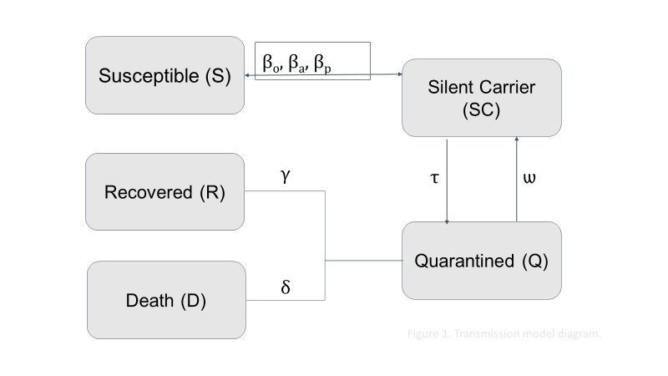
Figure 1: This flowchart illustrates the transmission of the COVID-19 virus for workers in movie theatres
To achieve this benchmark, I had to understand how the ODE system was constructed from the real-world pandemic scenario within the context of a business reopening environment by modeling how various populations (susceptible, silent carriers, recovered, quarantined, and dead) interacted with each other in a business framework. This interaction is best represented in Figure 1 above which contains a flowchart that illustrates the transmission of COVID-19 between populations. For example, δ represents the proportion of quarantined individuals who die. Using the variables (S, SC, Q, R, D) and the parameter values, the following differential equations were created:

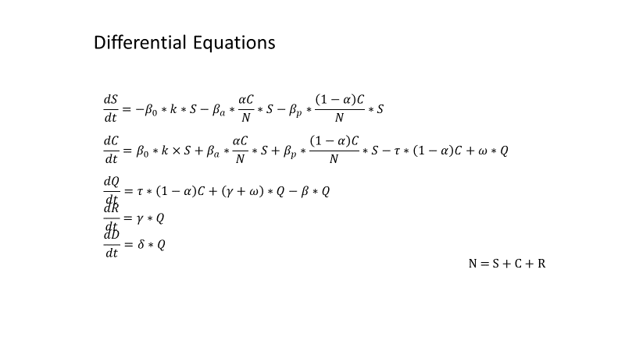
Figure 2: The Ordinary Differential Equations
One thing I learned was that in the above ODE system that a certain % of S, the # of susceptible workers, become silent carriers due to either being infected at work or outside of work. The second differential equation then represents that the number of silent carriers C increases by the same amount. This phenomenon is preserved throughout the model so that the rate of change of the entire population, living and dead, is zero, so that the total number of bodies are conserved.
After understanding the nonlinear differential system, I recreated the simulation results from the Maio paper by numerically solving the system using Mathematica. As I mentioned before, I had never used any Mathematical software before, so this was a bit of a challenge. The first graph I created was the general solution to the ODE system where time was allowed to evolve for 200 days.
For simplicity, in the above simulation, the number of susceptible people was set to 299, silent carriers to 1, and the rest to 0. In this graph, none of the health guidelines recommended by the Centers for Disease Control and Prevention (CDC) were followed. These guidelines are: (1) Social Distancing, (2) Personal Protection Equipment for staff members, (3) Routine Sanitization, (4) COVID-19 tests accessible for staff members, (5) Deployment of non-contact sensors, (6) Case Reporting and quarantine policy, (7) Determination of a maximum time duration of exposure to working environment, (8) Specific equipment (e.g., stronger ventilation system, UV purification system) for aerosol transmission prevention, (9) Employees in non-contact positions remain working from home. Lastly, the model was solved by using the parameter values the Miao paper recommended.

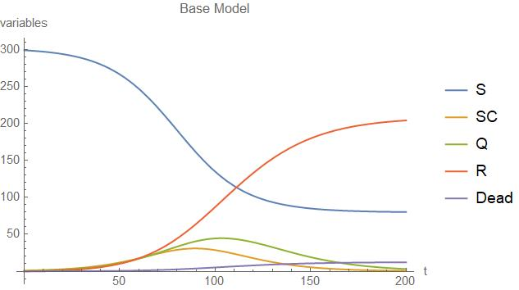
As seen in the figure down below, the number of susceptible workers drastically decrease from its initial value to around 100 while the number of silent carriers steadily increased before reaching a peak of 50 cases before going down to 0.
Figure 3: Initial Solution to the ODEs (t=200)
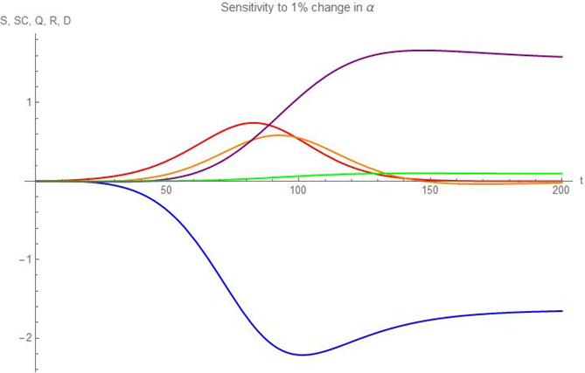
Next, I worked on sensitivity analysis to further understand the paper. The below graph shows the change in the solutions for S, SC, Q, R, and D relative to their original values after a 1% change in the parameter α:
Figure 4: Sensitivity to 1% change in Alpha

Figure 4 suggests that the transmission model is not sensitive to parameter value changes and therefore the model is capable of making robust predictions for error in α. Thus, I started working on expanding the current model to make it more realistic. This was repeated for all model parameters without revealing significant model sensitivity to its parameters.
After, I surveyed people on their thoughts about what health guidelines movie theatres should implement for them to attend movie events. The most popular guidelines were: Social Distancing, Personal Protection Equipment for workers, Routine Sanitation, COVID-19 regular testing, and non-essential workers working from home. Using the result, I was able to modify some of the parameter values of the differential equations and created the following graphs:
Furthermore, for a business to reopen, it must have high revenue relative to costs. This graph illustrates that successfully and without using any vaccinations, this movie theatre can run successfully by following the guidelines above.

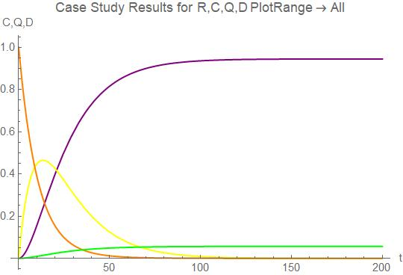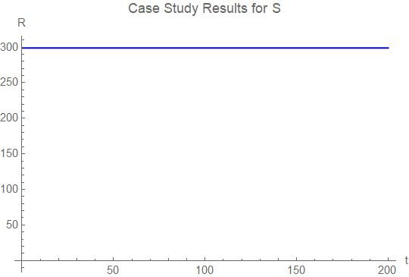
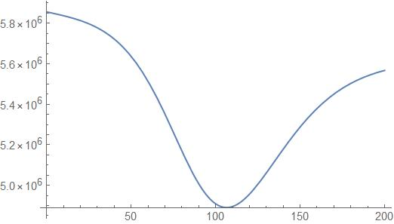
Figure 5,6: Case Study Results

Figure 7: Net Profit
In my project I then modified the base model to include the presence of a vaccination option, as seen in Figure 8. (see figure down below)
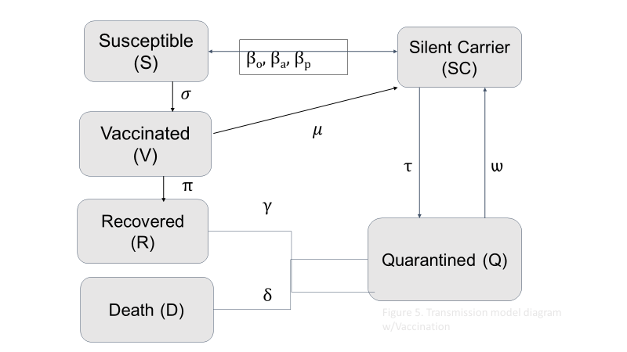
Figure 87: New Transmission Model Diagram with Vaccination

Susceptible workers are assumed to be vaccinated daily at a rate of ρ while recovered people can also be vaccinated at a rate of π. However, there is still a small chance of vaccinated workers being infected at a rate of µ. Using this, the following results were created:
As shown in the graph, the number of infected people is reduced significantly when the vaccination model is introduced to the existing transmission model. Since the number of silent carriers are decreased, the number of recovered, dead, and quarantined workers are reduced to a certain extent as well.
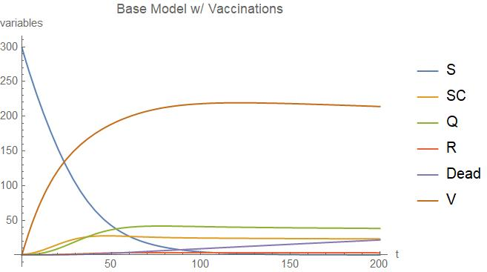
Figure 9: Solution when Vaccination model is added to the diagram

III. Conclusion
FURSCA was very successful for me as I was able to dive into real-world problems and figure them out on my own. Furthermore, seeing that I am a Mathematics major, it was important to learn how to decipher mathematical papers and models as well as code and generate solutions and their graphs by myself. Not only did I learn much more about mathematical modeling, computational software, and how their use is important to movie viewers in the sense that such models can be used to help business plan how or if they should reopen under a variety of circumstances. After graduation, I would love to work for a company in the cinema industry on the business side (e.g. data science) where this experience could be a significant advantage for me. Lastly, I will be using my research for my honor’s thesis as well participate in the Elkin Isaacs Symposium.

Future Work

Due to lack of resources, I was not able to add as much as I wanted to the flowchart (i.e. what rate of infected people recover from COVID-19 without being tested).If I were to continue to conduct this research, I would work on finding how to incorporate additional agendas onto the transmission model diagram as well as finding rates for those agendas so it is solvable.

Bibliography

Miao, H., Gao, Q., Feng.H, Zhong.C, Zhu.P, Wu.L, Swartz.M, Luo.X, DeSantis.S, Lai.D, Bauer.C, Pérez.A, Rong.L and Lairson.D, “Mathematical Modeling of Business Reopening When Facing SARS-CoV-2 Pandemic: Protection, Cost, and Risk” by . Frontiers in Applied Mathematics & Statistics, 6, No. 35, 2020.

