End of Summer Report
Disc Golf Intervention
Tyler R. Hood
Dr. Julie Cousins
July 24, 2021

This was an amazing summer filled with great successes, early mornings, late nights, new relationships, and dedicated work. Specifically, I worked with Dr. Cousins to implement an 18-participant intervention on being physically active through playing disc golf for at least 9 holes, 3 sessions a week for 6 weeks. Half of the participants would be in a control group, and the other half of the participants would be in the intervention group. Thanks to FURSCA funds from the Orpha Leiter Irwin Fellowship, I was able to purchase the intervention group’s materials which were an optional bag, 10 sets of discs (see picture below), paper for a colored map of Victory Park’s course, a score card, and 2 beautiful brochures with instructions of how to throw a disc and play disc golf. At the beginning of FURSCA, I aimed to work as a team with Dr. Cousins to have an amazing FURSCA experience. Also, I aimed to recruit 16 individuals through social media, Albion Today, emails, and other platforms. Also, I aimed to take these participants through a pre- and post-test on their demographics, mood, body composition, balance, and tracking their physical activity for 72 consecutive hours. The last goal was to create hand-drawn signs that would be converted into metal signs for Victory Park’s disc golf course through an external company called Chain Reactions.

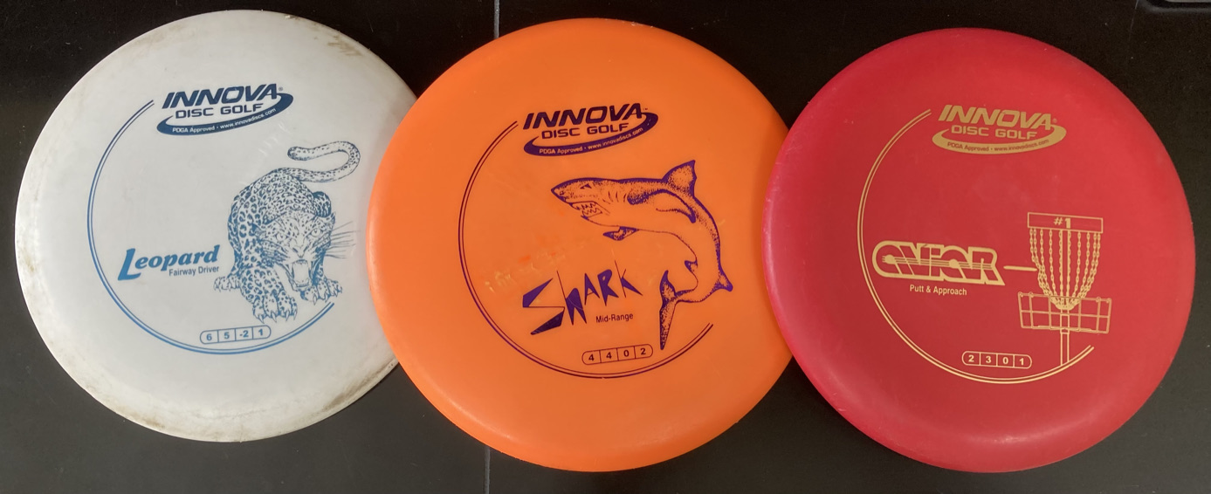
The outcomes of these goals and aims were outstanding! First off, the number of participants that I recruited was raised to 18 individuals thanks to Renee Kreger and Troy Kase who supported me through their emails and invited me to a faculty/staff gathering! Therefore, 18 pre-tests were administered; however, one of the participants had to be withdrawn during the study. Therefore, I administered 17 post-tests within the span of 1.5 weeks. Also, the results of the 2 groups’ tests were analyzed from a 2-way ANOVA and the analysis found some pretty amazing results (check graphs below for further details). Even though none of these results were significant due to the small sample size, the results were encouraging for future studies. First, the intervention group increased their skeletal muscle mass in their right arm by almost a half-a-pound in just 6-weeks! Secondly, the intervention group increased their skeletal muscle mass in their torso by more than 2.2 pounds! Even though, neither of these findings are statistically significant, more participants in future studies may show more promising results.

Right Arm Skeletal Muscle Mass
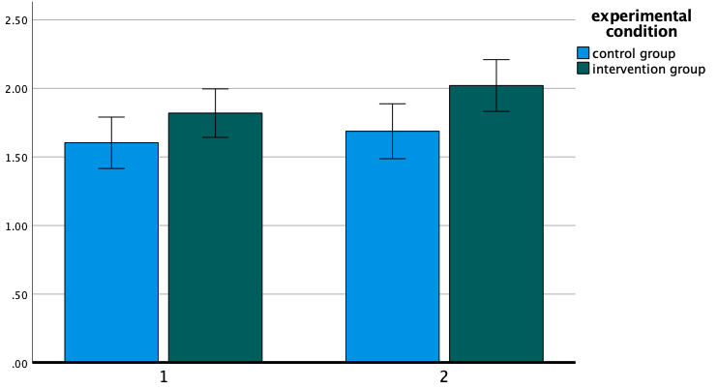
Pre-test Post-test
Skeletal muscle mass (kg)

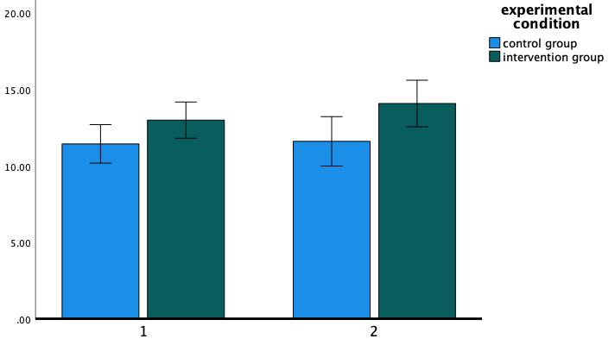
Torso Skeletal Muscle Mass
Pre-test Post-test
Skeletal muscle mass (kg)

Also, there were some pretty interesting changes in mental health. When comparing the Depression, Anxiety, and Stress Scale taken during the pre- and post-tests showed that anxiety decreased at a higher rate in the intervention group compared to the control group. Specifically, the intervention group decreased by one full point, but the control only decreased by a third of this amount (0.375). Another part of mental health was stress, which was increased in the control group. Contrastingly, the intervention group decreased their stress levels by 0.223. Lastly, the results from the Brief Mood Introspection Scale showed that the control group increased in tiredness over the 6 weeks; however, the intervention group increased in positivity (see graphs below for further details)!
Overall Anxiety Score

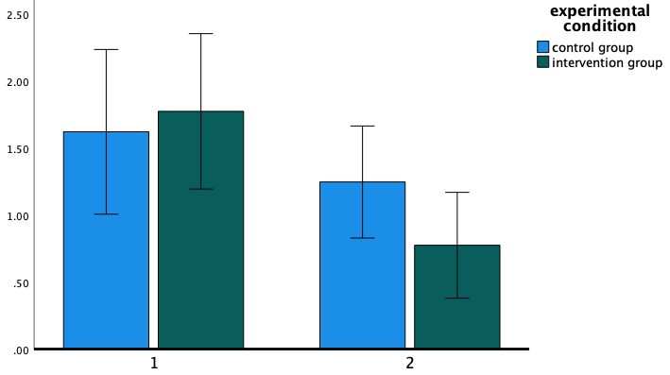
Pre-test Post-test
Anxiety Score

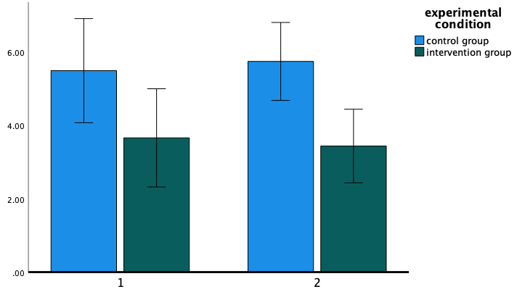
Overall Stress Score
Pre-test Post-test
Stress Score
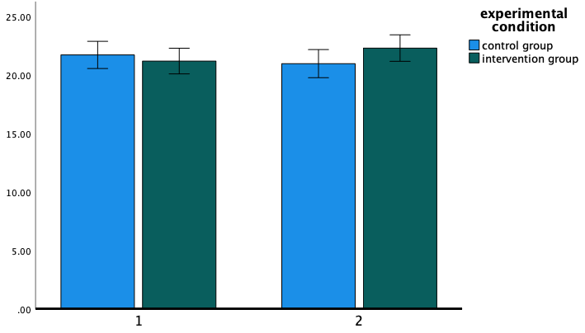
Positive-Tired Mood Score
Pre-test Post-test
Positive-Tired Score

One of my favorite parts of this FURSCA experience was to go to the Victory Park disc golf course and create drawings of the holes. Below you’ll be able to see the progression of creating the signs from the drawings of hole #1, which came out amazing (and all of the signs came out amazing)! The process was to copy each hole on a lined sheet of paper with all of the hills, water errors, trees, bushes, and other obstacles from the cement tee pad to the basket. After they were drawn, Dr. Cousins and I edited and revised each of these on a printer paper numerous times (see pictures below for further details). After the revisions were completed, we sent them to the sign creator to create the final signs after chatting with them on the phone for numerous hours. Also, these signs couldn’t have been made without the funds from the Sindt Experiential Learning Fund, which I applied for and was the first student to be funded by this fund. Thank you, Peggy Sindt, for the funds in order to make this experience possible.

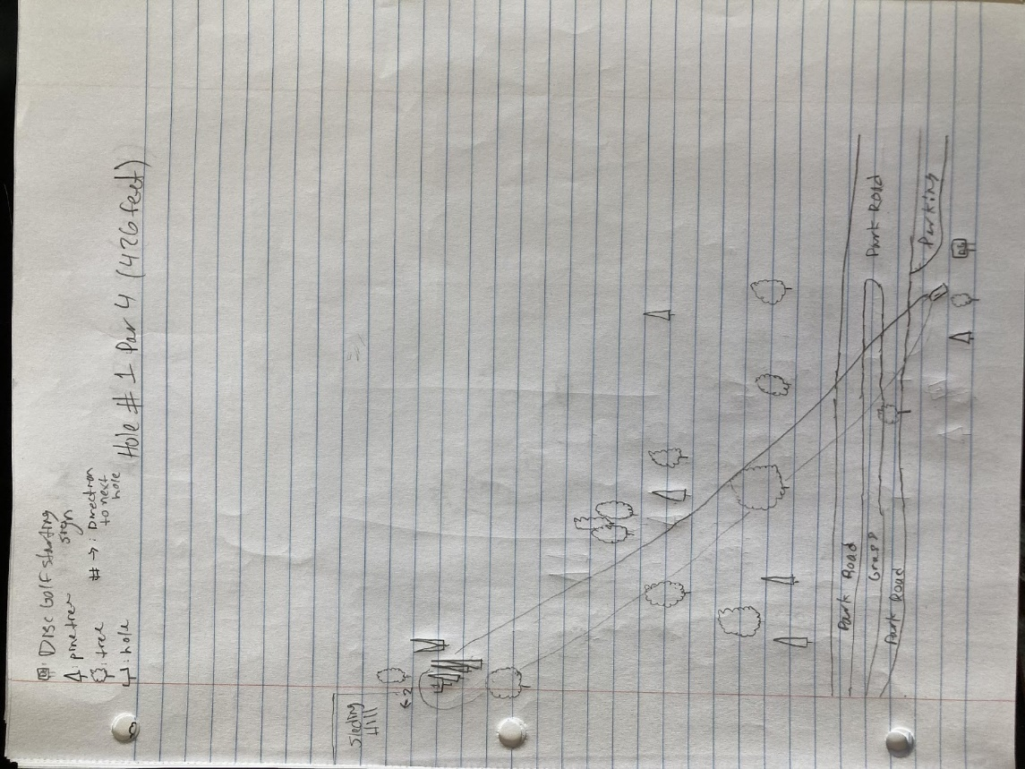
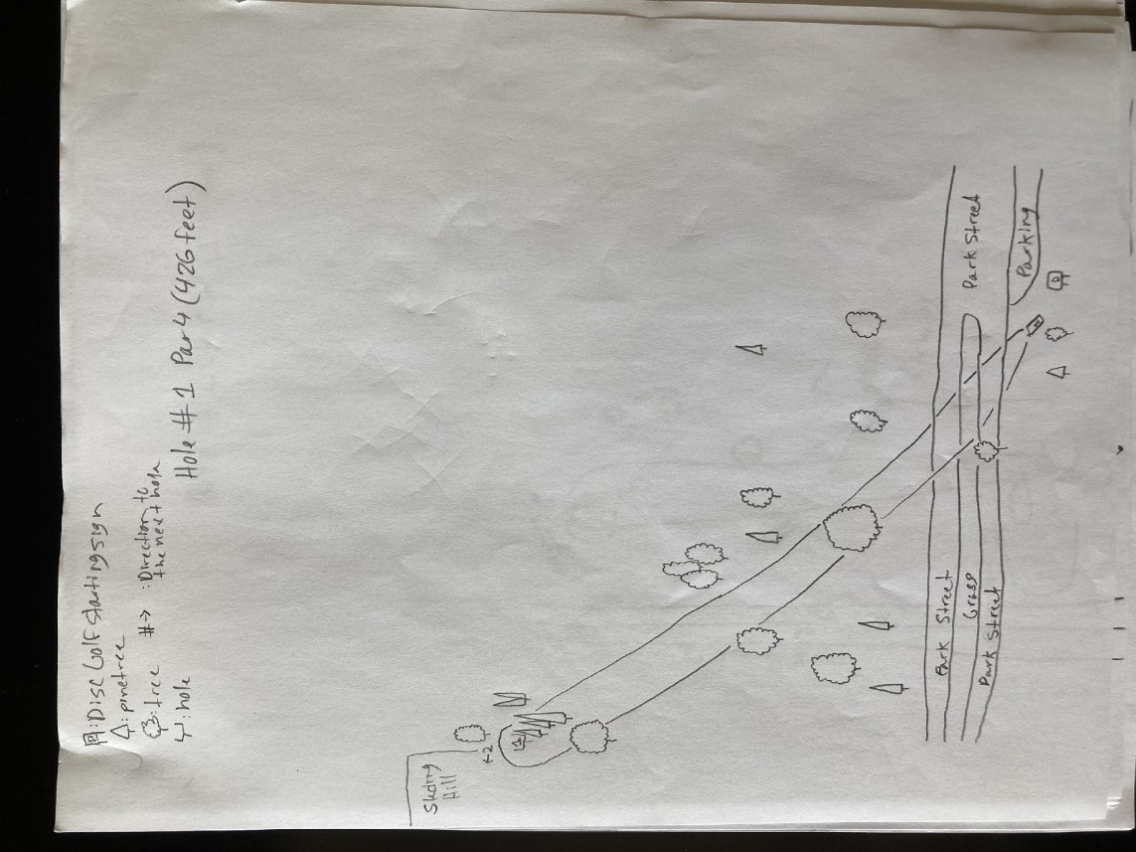
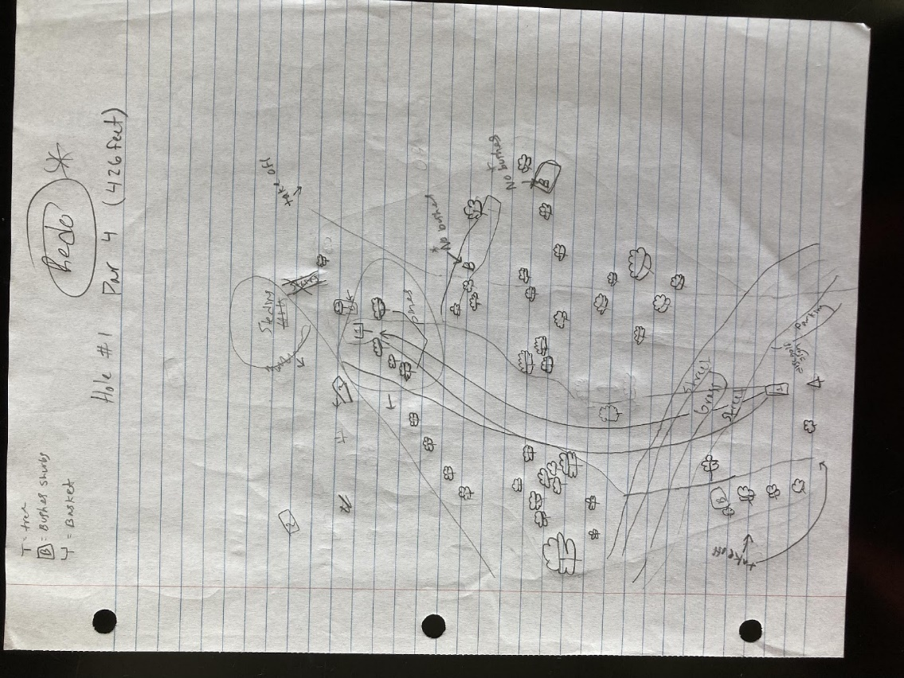
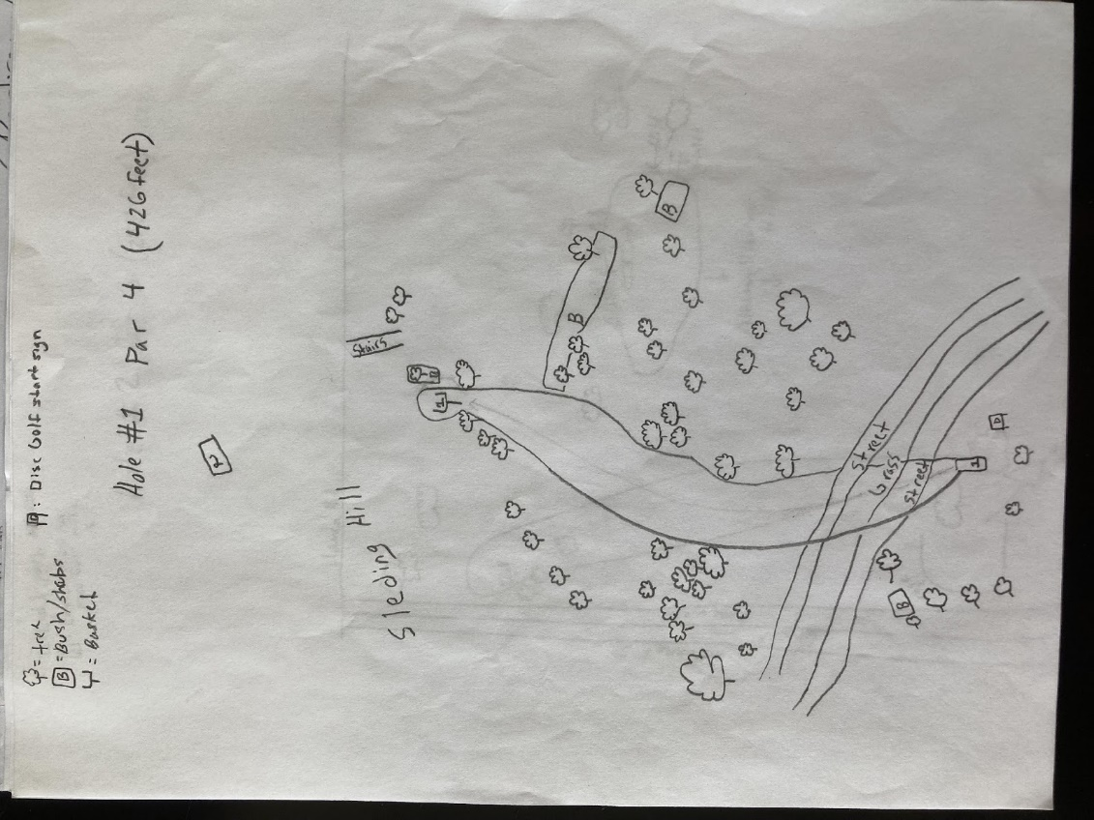

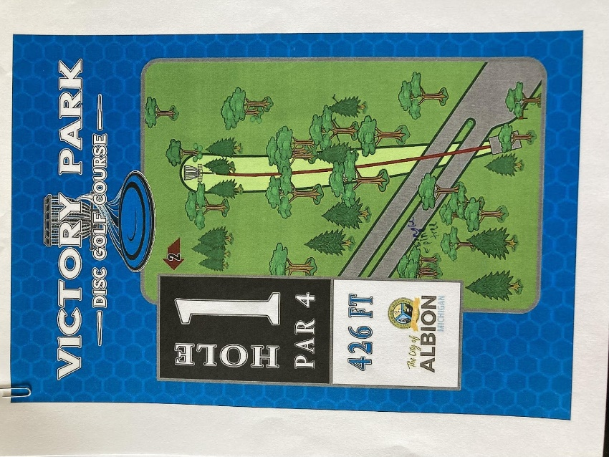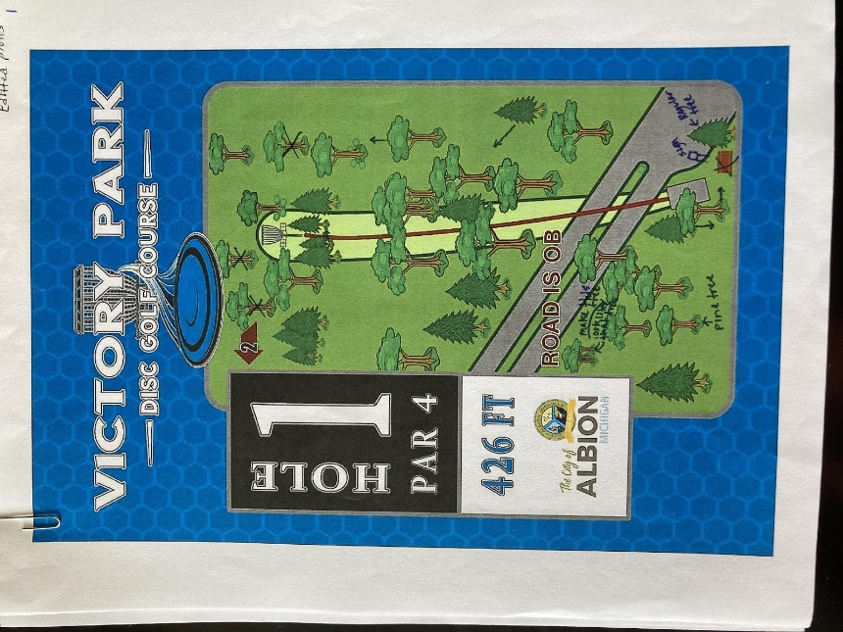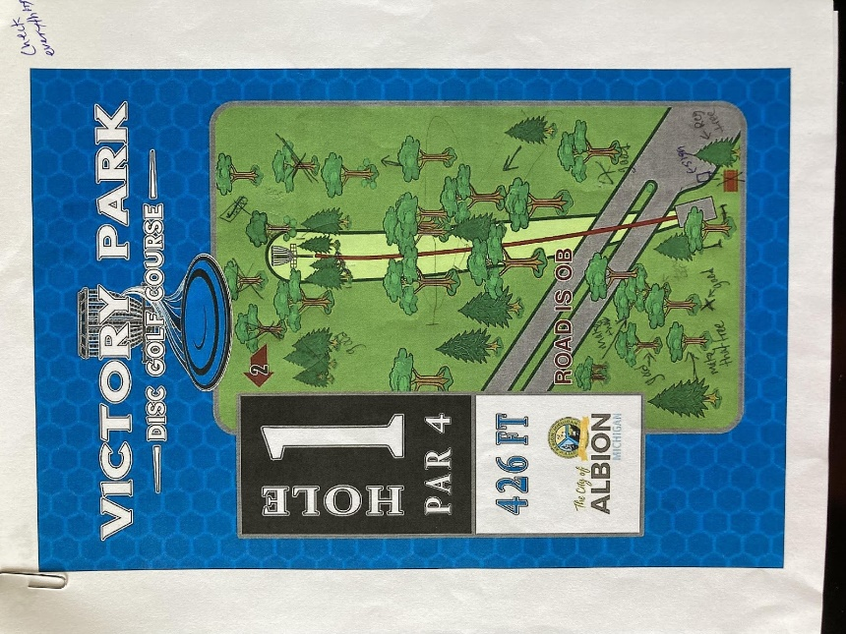

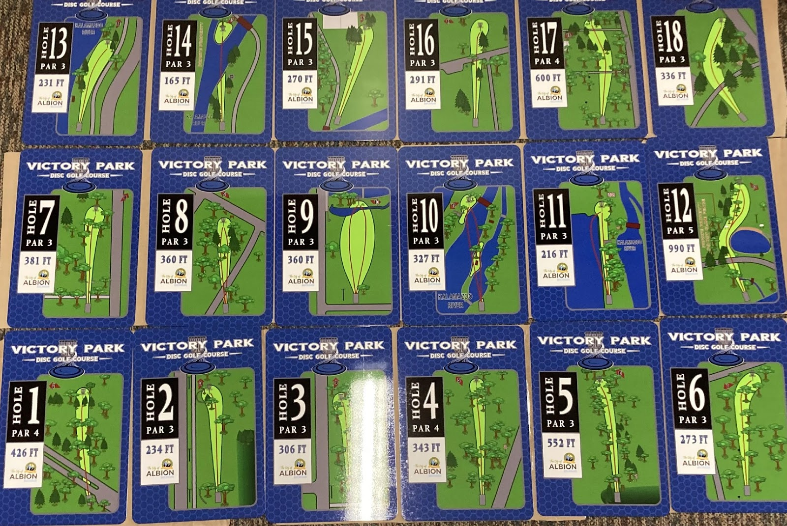

This project was a lot of hard work, but progressed smoothly, and finished with a successful back flop into bed to relax. Even though the FURSCA duration may be over, there is still a lot more work to be done, which is super exciting for myself and Dr. Cousins. This project helped to support previous research on how important physical activity is even if it isn’t running or lifting weights. From here, Dr. Cousins and I are in the process to continue this project and make this project a pilot study for Albion College. In the next study, we hope to answer other questions like whether disc golf can improve grip strength and other variables as there is still so much more that I have questions about. Also, another future plan is to submit the finished copy of the article that we have put together by the fall.
The sport of disc golf was very fun to play by myself and with friends. I hope to continue it in the coming months and years. Also, this research study has helped me immensely. Through this study, I continued to learn how helpful Albion College and the City of Albion are in helping me with my education and passions. Also, I learned that if I ever needed any help or support to ask for it, as there are so many possibilities at Albion College that I urge to explore further. Lastly, this project taught me how to work with my brilliant supervisor, Dr. Cousins; administer tests on participants; analyze data through SPSS and understand the analyzations; work as a team in a science field; and how to help and support other researchers to create a community bond and build relationships in the FURSCA community.
Thank you for allowing me to participate in this FURSCA experience and for supporting me along the way! I’m excited for what the future of this research project will hold for myself and Dr. Cousins. All the best, the newborn researcher, Tyler R. Hood (Class of 2021).

