Samantha Brand
FURSCA End of Summer Report
My project sought to explore how gender impacts the effectiveness of negative campaigning. In order to research this I ran a study which tested how different types of negative campaign advertisements (policy and personal) were viewed when used by male vs. female candidates. Participants were shown one of four advertisements (1. Female Personal Attack Advertisement, 2. Female Policy Attack Advertisement, 3. Male Personal Attack Advertisement, 4. Male Policy Attack Advertisement) and then took a survey regarding their opinions on both the target of the advertisement and the candidate who sponsored the advertisements. This survey included the participant’s likeliness to vote for the candidate and how likely the felt candidates were to possess qualities. In addition, participants took a survey which measured their level of sexism. These survey results were then used to analyze participants' gender perception of candidates when using negative campaign tactics. The goals of my summer research were (1) to develop negative campaign advertisements that depict each of my four proposed groups, (2) to identify the scales I will use in measuring the effects of campaign advertisements on participants perception of candidates, (3) to identify participants and conduct my study to explore how different negative campaign tactics and gender impact constituent opinions on candidates, and (4) to complete the compilation of data for my experiment and compare it with my previous research.
During my summer FURSCA project I was able to achieve all of my goals. I was able to develop four negative campaign advertisements which I modeled after real negative campaign advertisements in recent elections and represented each of my four groups. Next, I was able to identify the scales I used to measure effectiveness on campaign advertisements through the use of Faucets of the Big Five Personality traits. Then, I was able to obtain participants using Amazon’s Mechanical MTurk survey database and conducted my study with a total of 340 participants. Lastly, I compiled the data from this experiment and compared it to previous data records through a formal write-up of my research, thus obtaining all the goals I had set for myself at the beginning of the summer.
While obtaining these goals, I was able to collect a multitude of results but those most pertinent are the participant’s likelihood to vote for each candidate. When voting for the targeted candidate, participants were more likely to vote for the female candidate. In addition, in the target group participants were more likely to vote when it was a personal attack advertisement versus a policy attack. In contrast, in the sponsor group participants were more likely to vote for the male candidate. This was interesting, because regardless of if a person had sexist views, they were implicitly more likely to vote for a male name vs. a female name knowing nothing else about the candidate. At the end of the document you can see these main results written up in proper psychology format as well as the graphs indicating these results.
This project is important due to the insight about campaign tactics based on gender it provides. This information can be used to strategize campaign tactics in future campaigns. In addition, this project is particularly pertinent to my future as a researcher because it is the basis for my senior thesis project. In the Fall, I plan to conduct a follow-up study which explores what occurred when a male candidate attacks a male or a female candidate attacks another female. This information combined with the data I collected this summer will make up my senior thesis project. In addition, I plan to present this research at Elkin Isaac in the Spring. Finally, this experience has helped me shape my future as I plan to pursue a PHD in School Psychology. Through FURSCA, I have gained valuable research experience in the psychological field which will help me be prepared for research in graduate school. This experience also illuminated my passion for research, helping me further cement my intended career goals.
I would like to thank my advisor Dr. Andrew Christopher for helping me develop and complete this project. Also, thank you to Renee Kreger and Vanessa McCaffrey for their work setting up and organizing FURSCA this summer. Finally, thank you to the Bethune Fellows Student Research Endowment. Without your generous support, this research would not have been possible.

Results Write-Up In Psych Format
Likeliness to Vote Target
In Step 1 we found significance in total sexism, candidate gender, and ad type accounting for .297 DR² where more sexist participants were more likely to vote for candidates overall (p < .01), the female candidate was likely to be voted for (p < .01), and participants were more likely to vote when it was a personal attack (p < .05). In Step 2 we found significance in gender x sexism (p < .05) accounting for .028 additional DR² where in sexist people were more likely to vote for the male candidate compared to nonsexist people. There was no further significance found in step 3.
Likeliness to Vote Sponsor
In Step 1 we found significance in total sexism accounting for .153 DR² where more sexist participants ranked candidates more withdrawn (p < .01). In Step 2, we found significance in target gender interacting with sexism accounting for .039 additional DR² . Here, participants were more likely to vote for the male candidate (p < .01). There was no further significance found in step 3.

Graphs
Likeliness to Vote- Target
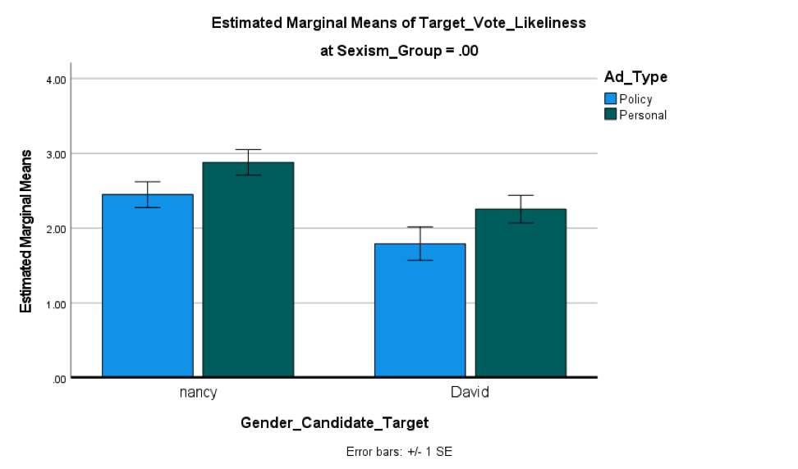 | 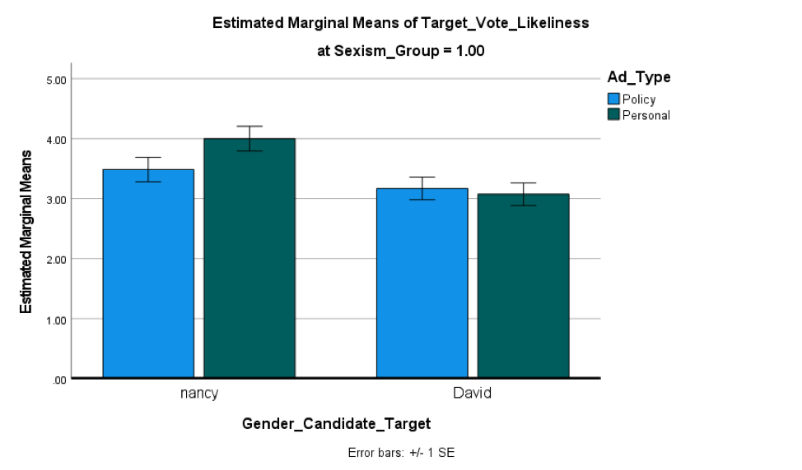
Gender <.001 -> More likely to vote for Nancy
Ad Type .017 -> More likely to vote when it’s a personal attack

Likeliness to Vote Sponsor
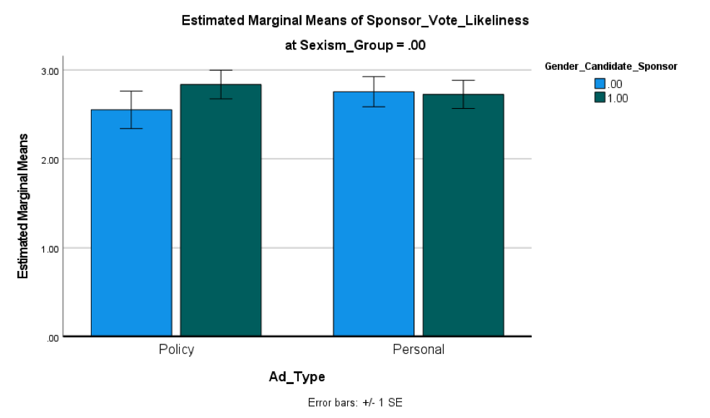 | 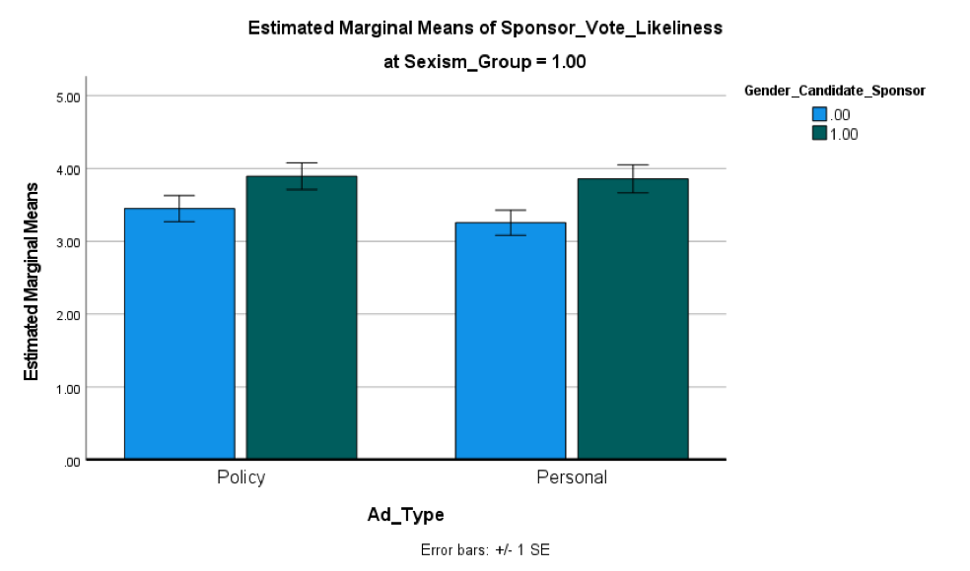
Gender .011 -> More likely to vote for David

