Richard K. Vitek, ‘56 FURSCA Endowment Fund
This summer, my goal was to research how electrochemical methods can be utilized to reduce Bromate, a Contaminant of Emerging Concern (CEC), into a safer Bromine ion. The overarching goal of my project is to reduce bromate into bromine via carbon microsphere modified electrode. Current electrochemical remediation utilizes platinum, a notoriously expensive metal. Effective use of a microsphere modified electrode would provide a reasonable alternative by using either less platinum or entirely cheaper materials. This research is in pursuit of a more economically realistic remediation solution that would benefit the efforts to remove oxyanion contaminants such as Bromate, Chlorate, Perchlorate, and Nitrate. Goals throughout the summer included; familiarizing oneself with potentiostat and chromatography instrumentation, comparing various electrodes, designing chronoamperometry and cyclic voltammetry experiments, and synthesizing carbon microspheres using previous research conducted in Metz’s lab.
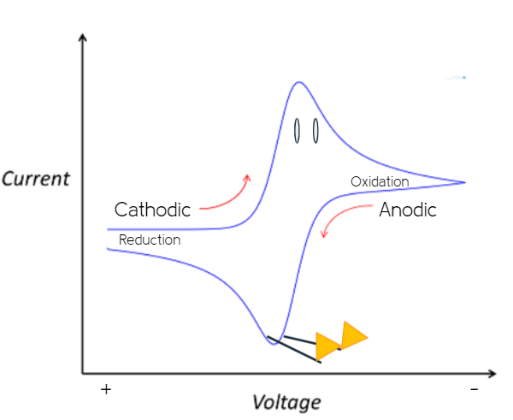
A number of goals were achieved over the course of the 10-week period. I not only became familiar with 2 potentiostat instrumentation programs but also routinely worked with the ion chromatography system of the Albion Dow laboratory. The use of the Pine WaveDriver 100 potentiostat allowed chronoamperometry and cyclic voltammetry experiments to be performed multiple times a day. By far, most of my research was conducted using this instrument. The data collected using these forms of experimentation gave insight into the electron transfer energetics of bromate solutions in an electrocatalytic cell. Normally, the peaks indicating oxidation and reduction shown on a cyclic voltammogram loosely resemble ducks. The majority of the data yielded were poor excuses for ducks, however, please enjoy this artistic interpretation of a voltammetry duck.
Although dozens of goals reached were in relation to furthering research, even more were personally related to broadening my studies. The time I spent at Albion participating in FURSCA as a rising sophomore provided me with my first experience in a lab of any kind. Before electrochemical experimentation could begin, I got started by studying the basics of electrochemistry with Dr. Metz. Electrochemical methods are not something most undergraduate students even consider looking into. The content itself made my research experience unique. However, I am proud of the time I spent practicing lab soft skills such as record keeping and properly communicating with fellow researching peers.
This experience helped me define my goals both at Albion College and beyond. Early in my college career, I aimed to reach out for new opportunities. Now that I can proudly say that I have and that it paid off, my future career in chemistry has become crystal clear. At Albion, I will continue to rouse curiosity and extend my network of peers, educators, and other scientists. The Elkin Isaac symposium will act as an excellent platform to do just that. I believe that will aid in adequately preparing me for a future in academia. The conversations I have had with other researchers and mentors while conducting research fully convinced me that I should begin preparing for graduate school.

