Nathaniel Jennings
Advisor Dr. Phil Voss
FURSCA - End of Summer Report
July 23, 2021

As a first time FURSCA student this summer, my partner Daniel McGarry and I sought to build a model rocket with thrust vector control (TVC) capabilities for the purpose of auto stabilization during flight. With advancements in computer-aided design and 3D printing technology, implementing TVC technology into model rockets is something that has just begun to be experimented with by average model rocket enthusiasts. The goal of this project was to develop a model rocket with TVC technology and publicly share all our gained hardware and software knowledge to help advance the field of model rocketry.
For this group project, Daniel focused on software development, while I concentrated my efforts on designing, printing, and building all the necessary hardware components for the rocket. These engineering projects included, first and foremost, a gyro-like device that allowed our rocket engine to gimbal on two axes with up to eight degrees of freedom. A nose cone, shaped optimally for sub-supersonic flight, was also designed. To eliminate the need for a rocket engine ejection charge, a spring-loaded parachute ejection system was also developed. The on-board microcontroller and computer chips, necessary for giving commands to all our mechanisms, were given a specially designed mount optimized for easy assembly and outside access to our laptops via a micro-USB cable. Some parts for the computer mount were also designed to protect the computer from the heat of the rocket engine, and to allow the placement of a GoPro inside the rocket to observe our code and gimbal in action. To test our PID algorithm and tune it properly before launching our rocket into the air, ground tests of our software and hardware systems were required. To do these tests required the building of a large gyro. This device was mounted to the outside of the rocket body and allowed the rocket to pivot 45 degrees on two axes, ensuring that we could properly test our algorithms and observe any errors or weaknesses in our technology. To save money and time on engines and PID algorithm tuning, a brushless DC motor, equipped with a 10-inch rotor blade, was reutilized, and given a specialty designed mount so that it could be used in ground testing in place of live engines. A small locking mechanism was also created so that we could run ground tests with the rocket in various orientations. Each of these engineering projects were completed using a 3D design program called Blender. Slicing software was provided by MakerBot, and all 3D printing took place in the engineering lab on a MakerBot Replicator. The Blender and STL files of each part of this project is available on these GitHub and Thingiverse links:
https://github.com/NJ-FURSCA-2021/TVC-Rocket_2021/tree/main/CAD
https://www.thingiverse.com/nathanielwj/designs
In addition to the most recent designs, every iteration of each project was also uploaded to GitHub for anyone who is curious to see how the design process progressed.
As of the writing of this report. Daniel and I have completed successful PID tuning and hardware ground tests using both our rotor and live engines. Successful flight stage tests were completed using an elevator, as well as a parachute deployment test in the atrium. After three attempts, we were able to get the PID algorithm to execute properly during an unaided flight. By the end of this week, or possibly later this fall, we hope to conduct more launches using more powerful and longer-burning motors to further demonstrate the capabilities of our rocket.
Being a part of FURSCA this summer allowed me to get first-hand experience on what it is like to be an engineer and gain some career related skills. This summer, I was able to get a ton of time learning computer-aided design software. I had to solve many problems and had to learn to innovate and change models to meet the needs of the rocket and our programmer, Daniel. I learned all about the process of 3D printing and the importance of knowing how to choose the correct printing materials and print settings. FURSCA was a wonderful experience, giving me the opportunity to work independently as well as with a team. I would like to thank the FURSCA committee, our advisor Dr. Voss, and the Council on Undergraduate Research (CUR) for their support in making this project possible. I am very excited to present all our project discoveries and successes this coming spring at the Elkin Isaac Research Symposium.

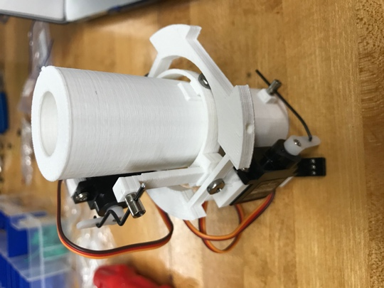

Figure 1: An early version of our rocket engine gimbal.
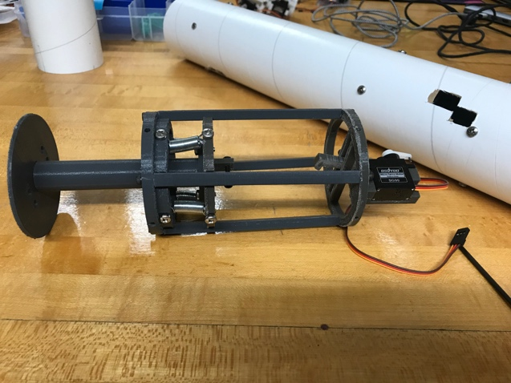

Figure 2: A late version of our spring-loaded parachute deployment mechanism.

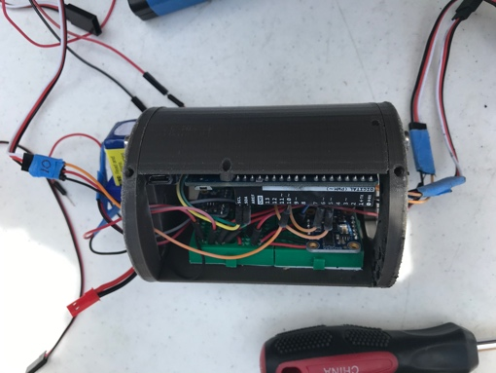

Figure 3: Rocket flight computer placed inside its mount.

