End of Summer Report

Identifying a Transcription Factor and Promoter for the Mating-type Genes of Tetrahymena thermophila

Bryce Vandenburg, Marcella Cervantes Ph.D.
Albion College FURSCA 2021

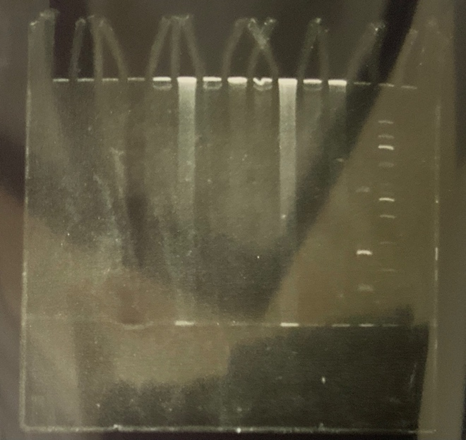
Over the past ten weeks I have been trying to solidify a proposed promoter and identify a protein used to induce the mating type genes of Tetrahymena thermophila. The mating type genes, MTA and MTB are co-expressed and are induced by starvation. This expression profile helped identify a control by keeping one sample fed and the other starved. Since the mating type genes only have a basal level of expression when the cell is in nutrients, it can be inferred that there will be no protein-DNA binding when the cell is fed, but there should be a binding complex when the cell is starved – when the mating type genes have much higher expression. To make the protein and DNA interaction visible an electromobility shift assay (EMSA) was used. By using this assay, multiple lanes were run on a polyacrylamide gel to see if a band shift would occur due to the binding of the protein to the DNA. When binding does occur, there is a larger mass to weave through the pores of the acrylamide gel, so it ends up shifting a band either up or down compared to the control lane with only DNA. The benefits of using the EMSA is it also will identify if there are multiple promoters working on the mating type genes to cause the induction of MTA and MTB. Over the course of the summer Dr. Cervantes and I hoped to be able to isolate the protein and DNA from the T. thermophila cells and start the EMSA to optimize the conditions in which the polyacrylamide gels need to be ran in.

Results / Summary
Over the course of the ten weeks, I was able to achieve most of my goals; however, due to some unforeseen issues with the polyacrylamide gel solidifying due to a chemical gone bad I was limited on the number of gels I made during the summer. Once the gel issue had been solved a few gels were able to be ran during the summer with one trial done with a full set of samples on the last day. Below is an example of the acrylamide gel run on the last day. In the first photo it shows the DNA staining which is shown under an ultraviolet light to highlight the DNA, which can be seen as the tight bands of white light.

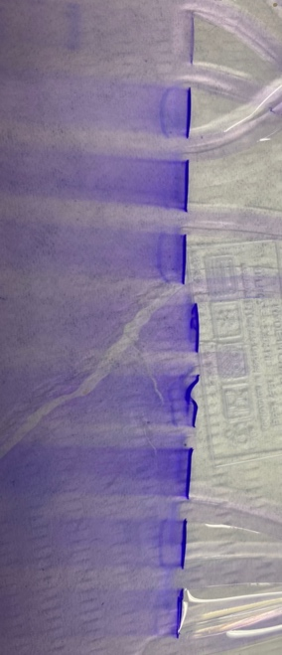
In the second and third photo shows it shows the protein staining, which is done on the same gel, but instead stains the protein. The first photo shows a zoomed in portion where the protein bands are more easily visible. The Second photo shows the whole gel. As seen in the first picture, those brighter blue bands are the isolated proteins that were collected; however, with them, being so high up the gel it is hard to see a shift between all the lanes.

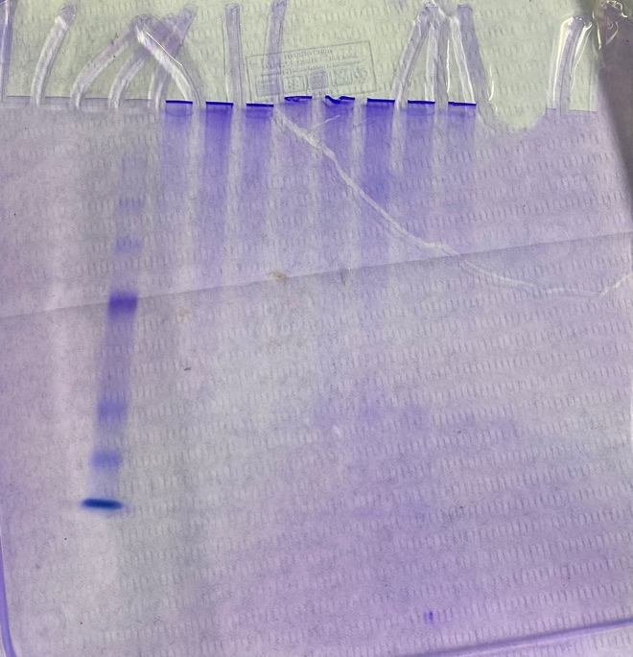
One of the next issues that will be worked out of the course of the next semester is how to shift the protein bands down the gel further to see a shift. Over the course of the next year, Dr. Cervantes and I plan to use this method to determine if the EMSA works for all seven mating types (sexes) of T. thermophila to see if the induction of the mating type genes is conserved. This same process will be performed on the remaining six mating types to determine if the protein – DNA interaction is the same among all of them.

Conclusion
Upon the completion of the project, I plan to use this experience to help determine my future in medicine. Before I apply to medical school, I wanted to have some research experience to determine if I wanted to continue research into my profession as a medical doctor. I have been debating between getting the traditional M.D or receiving a dual M.D Ph.D. degree and this experience is helping my determine if I would rather work directly with patients, or if I should work in a lab developing new medical treatments. Once I have finished my research over the course of the next two semesters, I plan on presenting the results at the Elkin Issac Research Symposium In the spring of 2022 and writing an honors thesis on the whole project.
This experience has taught me many new things not only about myself, but also about the whole research process that is not taught in the classroom setting. One of the first things learned is that failed experiments are normal and expected. Then through reasoning, experience, and collaboration with others, small changes are made until it can be deemed the experiment failed or it works. Through this you gain a new experience in how different things work in the lab. The process of figuring out solutions to problems you did not expect are crucial because it involves critical thinking and problem solving that is not only vital to the lab but is crucial to have in any job setting. I would like to thank FURSCA and the Orpha Leiter Irwin Fellowship for this opportunity to grow my scientific technique and skills, but also grow personally to encompass some of the necessary skills such as resiliency. Without their support and funding this project never would have been possible. With this knowledge on how the research process works combined with over 1,000 clinical hours at Henry Ford Allegiance Health, I plan to decide whether to dual degree in the next few months. I plan to write personal reflections on both my work at the hospital and my work in the lab to determine if research is something I want to expand and continue in my love for medicine for the rest of my life.

