End of Summer Report
For my Summer Project, my goal was to discover the location of the Hobo Element. Hobo is a known transposable element; however, the exact location is unknown. The first goal of my project was to first use PCR to determine which primers are best to discover the location of the Hobo Element. The next goal of mine was to get results from three different fly crosses that I set up, with more emphasis on the third and final fly cross because it is the most important. The final goal was to fully sequence the DNA that I got.
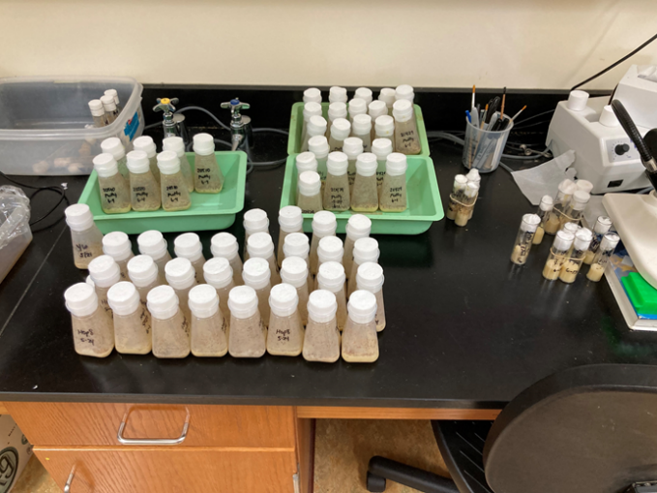
All-in-all, most of my goals were achieved. At the very end of my project, I did get a good PCR product that led me to sequencing the DNA and it showed that the known Drosophila sequence KH41 aligned with Hobo like what I thought. It took I little bit because using primers to get PCR is not as easy as it sounds. Eventually, I found some good primer combinations that led me to complete the first goal of mine for this project. In terms of my third goal, the final cross resulted in four white-eyed female and no males. However, this is good because that these female flies suggest that there might be a germ-line excision because the newborn flies will have one X chromosome from their mom (with white eyes) and one X chromosome from their dad (red eyes), but further sequencing will be needed to actually see if this is the case due to X-inactivation. As for my first goal, it is hard to determine if I successfully completed it, so further testing will need to be executed to determine success or not (the picture to the right is my fly bottles).
Much like with any science project there will be some results that do not add up and things will not always work out. Throughout my time researching, I have had numerous failed PCR products, gels, and fly crosses. However, even though these were failures, I did learn a lot from these failures. Quite possibly the most important aspect that I learned was how crucial it is to make sure that the virgin flies I collect are in fact virgins and females. I learned this the hard way when one of my experiments got messed up after a week of waiting for the results. In terms of the other failures, I learned to just try something else and keep pushing through it until I find the correct primers to use for the gels.
My project has a lot of importance to my future at Albion College and beyond. I am planning on attending medical school and genetics are a huge part of cancer and other diseases. I am getting little bit of background on genetics outside the classroom that will most definitely help me prepare for medical school. Not to mention this research helped me greatly with my summer genetics class I took. Moving onto my dissemination plans, I will be using this research for my thesis and presenting it at Elkin Isaac. Aside from this, I might be presenting my research at the National Drosophila Convention. Even without going to this convention, my FURSCA project has greatly impacted my life. Starting out with the research itself, I have gained more of an appreciation for genetics and geneticists because their job is not as easy as putting flies in a bottle and waiting for them to give birth. Moreover, I am much more careful aware of everything that I do not just in the lab but in every aspect of my life because of this experience. Moving onto outside of research, I have gained lifelong friends that I would never have met if it was not for this experience, so I am eternally grateful for being apart of FURSCA, with so many other exceptional students here at Albion College!

