SUMMER FURSCA End of Summer Report

Name of student: Marcelle Collares Date: 07/21/2021
Graduation Year: 2023 Major: Geological Sciences
Research Advisor: Michael McRivette Advisor’s Department: Geological Sciences

Title of Project: Source Parameters and Displacement of the Ridgecrest, CA, earthquake events, July 4-6, 2019, and Long-Term Regional Post-Seismic Deformation

Introduction

Ridgecrest is a city in California that has been near the epicenter of major earthquakes, including the July 4-6, 2019 earthquakes, which I have been studying. This last one was 8 km deep, and, according to the US Geological Survey (USGS), it was the largest earthquake in southern California since the magnitude 7.1 Hector Mine earthquake in 1999. The area in which the city of Ridgecrest is located is a very seismically-active zone in the ECSZ, an area that runs north-northwest from the southern end of the San Andreas Fault through eastern California. The movement of the Eastern California Shear Zone is 10-12 millimeters per year, which makes up 25% of the total movement of the North American Plate.
Geologists and geophysicists have been trying to find out how much the ground has been deformed after these earthquakes. By studying the source displacement and parameters of these earthquakes, we are able to learn more about the Eastern California Shear Zone and its relationship to the San Andreas Fault and plate motions. My goals were to acquire knowledge of data analysis software, learn to observe records and analyze data of deformation caused by earthquakes, have my first contact with seismology, since we do not have a specific seismology class for Geology majors at Albion College, and build my understanding on earthquake phenomena and how to interpret them using computer programs. In addition, I wanted to be able to present my findings at the Elkin Isaac Symposium and at the Geological Society of America Symposium in October 2021.

Results

My experience with FURSCA was a good learning experience. I have learned to produce interferograms and to fix all the errors that can happen when working with the SNAP STEP software. I have also learned how to interpret interferograms and to work with InSAR data, but since I have been through way more issues with the program, I was not able to include GPS data in my analysis. Below are pictures of my first try and my last one, that happened around 7 times later.
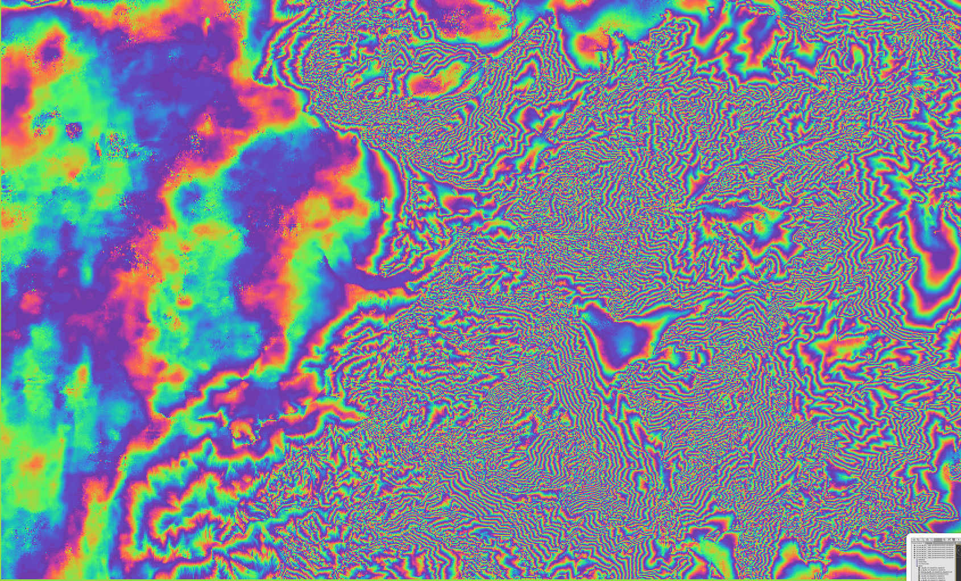
Figure 1: First interferogram tentative. No clear pattern was found.

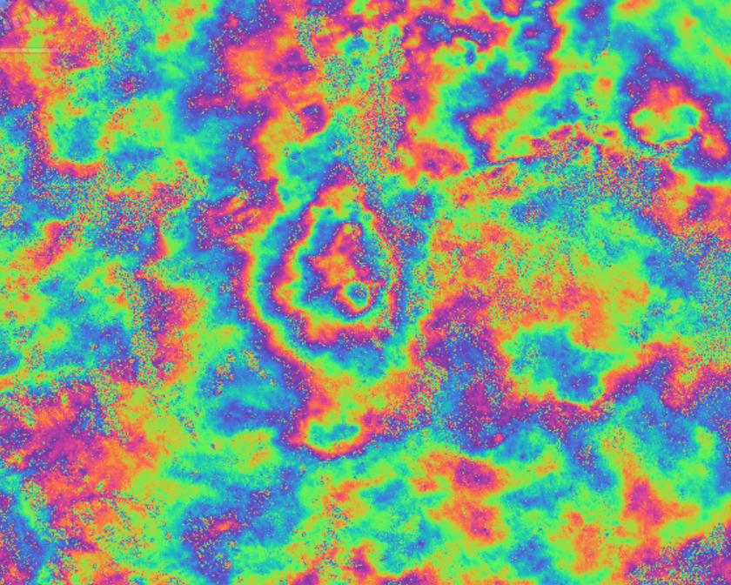
Figure 2: Last try. Clear pattern can be observed in the middle of the image. Concentric figure is located in the exact area where the earthquake occurred.

Conclusion

This project has been really important to me because it helped me not only understand how earthquakes can be measured and analyzed using computer programs, but also understand seismology is the path I want to pursue in graduate school. By having background knowledge and being able to show how passionate I am about studying earthquakes, I believe I will be a better candidate for the competitive Southern California Earthquake Center (SCEC) Undergraduate Studies in Earthquake Information Technology (UseIT) Summer internship I will apply to this coming Fall. It is also important for me to be able to help future Geology students from Albion College who have an interest in earthquake science. I hope I can support them both as a current student and as an alum.
My project has changed my perspective on research in Geology, and now I feel much more confident that I can be a dedicated researcher in the future. It has also given me the opportunity to connect with people in the area and ask them all sorts of questions, which made me understand what I could do to be a better scientist.
I will keep working on my project during the Fall, and I plan to disseminate my research at the American Geophysical Union (AGU) Fall Conference 2021 in New Orleans, Louisiana. I will also present my research at the Elkin Isaac Research Symposium next year, and possibly include my findings in my honors thesis, which I will begin writing in 2022.

