Slone Schultz
Summer 2019
End of Summer Report:
Oxygen Reduction Reaction and Peroxide Reduction Reaction using Platinum Nanoparticle Carbon Microsphere Composites

My participation in research this summer through FURSCA at Albion College was a challenging and rewarding experience. My project was based on promoting chemical reactions through the use of electrochemistry. The reactions this project was focused on was an oxygen reduction reaction (ORR) and a peroxide reduction reaction (PRR), in which both oxygen and peroxide were reduced to water due to an electron transfer. This reaction occurred due to an applied potential, promoting the electron transfer and reduction, which encompasses the theory of electrochemistry. According to Katsounaros et al., ORR and PRR has been completed successfully with a platinum disk as the working electrode, where the reaction takes place. The platinum disk in this case acted as a catalyst to drive this reduction reaction. The aim for this project was to promote the same reactions, ORR and PRR, with the use of Pt nanoparticle carbon microsphere composites (Pt CMs) as a catalyst on a glassy carbon working electrode. Previously, Pt CMS were used as a catalyst in electrochemical reactions, suggesting the same procedure could be used for ORR and PRR. Using Pt CMs would provide a much more cost effective method, and this catalyst has the potential to be more durable than a Pt disk or commercial Pt/C as found by Domínguez et al. In order to accomplish this goal, a thorough understanding of electrochemical theory and processes was necessary. Therefore, plenty of time was spent learning electrochemistry.
In order to have the Pt CM catalyst to run the electrochemical reactions, Pt CMs were made using ultrasonic spray pyrolysis. A system was used in which a solution of potassium dichloroacetate (KCHCl₂CO₂) and either 100 ppm Pt (Pt₁₀₀) or 200 ppm Pt (Pt₂₀₀) were placed in an essential oil diffuser to nebulize the liquid, turning the liquid into a mist. The mist then traveled to a furnace, using nitrogen gas as the carrier, where KCHCl₂CO₂ decomposed to form gaseous HCl and CO₂, which mostly dissolved in the bubbler that followed the furnace. The carbon, KCl, and Pt nanoparticles co-precipitated, and the KCl dissolved to form porous Pt CMs, which would be used as an electrochemical catalyst for ORR and PRR. The Pt CMs were then annealed to 900 degrees Celsius, because this was the most effective electrochemical catalyst as described by Domínguez et al.

Figure 1: SEM Image of Annealed Pt CMs
After some time in Albion this summer making Pt₂₀₀A900 CMs and Pt₁₀₀A900 CMs using USP, I travelled to Trinity College Dublin to further my research project. In my time there, I was engaging with graduate students who guided me in my learning of electrochemistry, since this is not a subject studied at Albion College. During my time at Trinity College Dublin, I was also exposed to instruments that are not available to me at Albion College. Using the SEM at Trinity College Dublin, images of Pt₂₀₀A900 CMs and Pt₁₀₀A900 CMs were obtained, as seen in Figure 1. The image shows the Pt CMs are porous, as they should have been due to dissolved KCl. At a high magnification, bright nanoscale spots were visible, which were most likely the Pt nanoparticles. Using EDS at Trinity College Dublin, it was confirmed that Pt was present in the CMs.
Also at Trinity College Dublin, I learned how to run electrochemical reactions as well as interpret them through computer programming. Several challenges arose in this process. Finding the most effective ink for the Pt CMs as an electrochemical catalyst as well as how to apply that to the working electrode was a long, yet necessary process. Also, determining what type of working and reference electrode to use for this particular reaction was essential. Electrodes have extremely sensitive contacts to the system as well as the reaction solution and its pH. In addition, the potential in which this reaction takes place in was determined as well as the scan rate that would provide the best results. I learned to appreciate the complexity of electrochemistry as my learning continued. By the end of my time at Trinity College Dublin, an effective setup for running ORR and PRR was determined. Additionally, some promising results were obtained with the commercial 20% Pt/C catalyst for ORR and PRR, which suggest our carbon based catalyst may be effective as well, as Domínguez et al. found in their work.
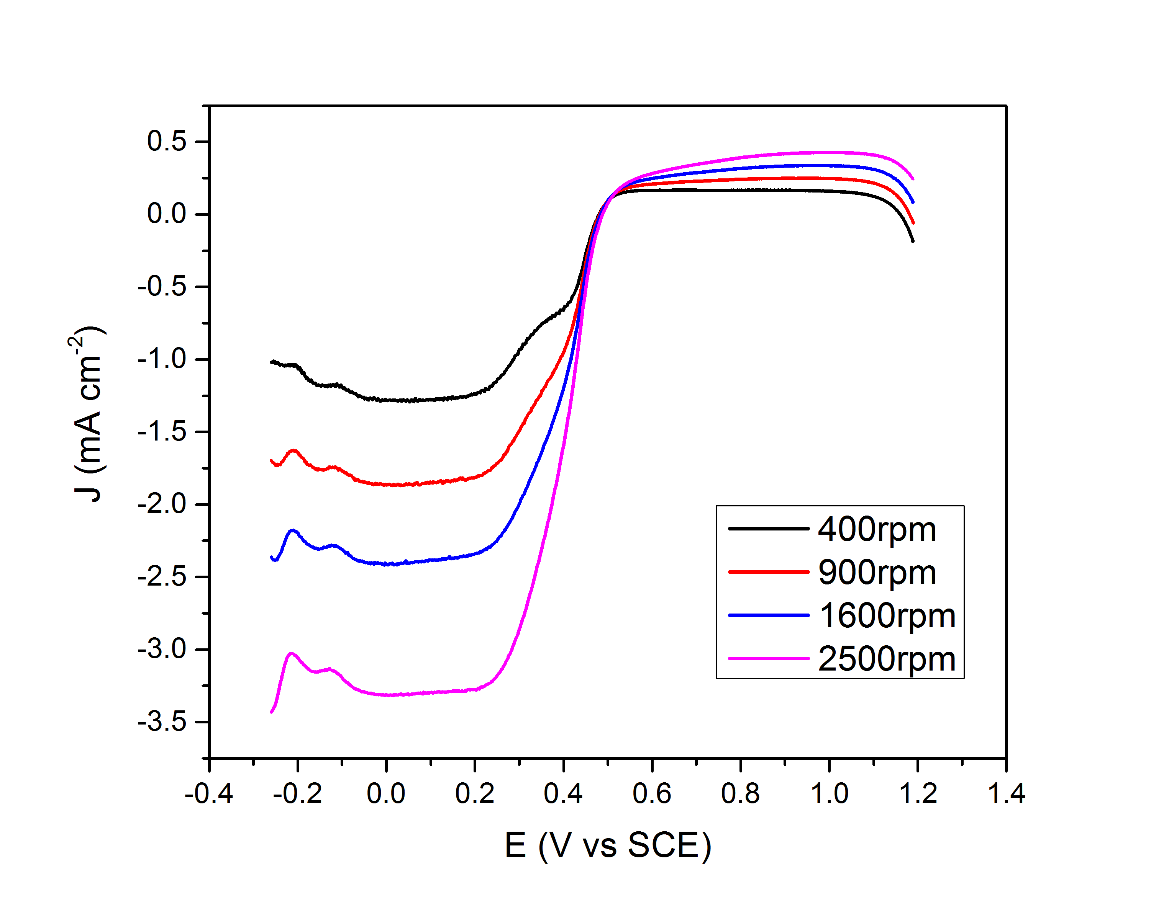
Figure 2: ORR with 20% Pt/C
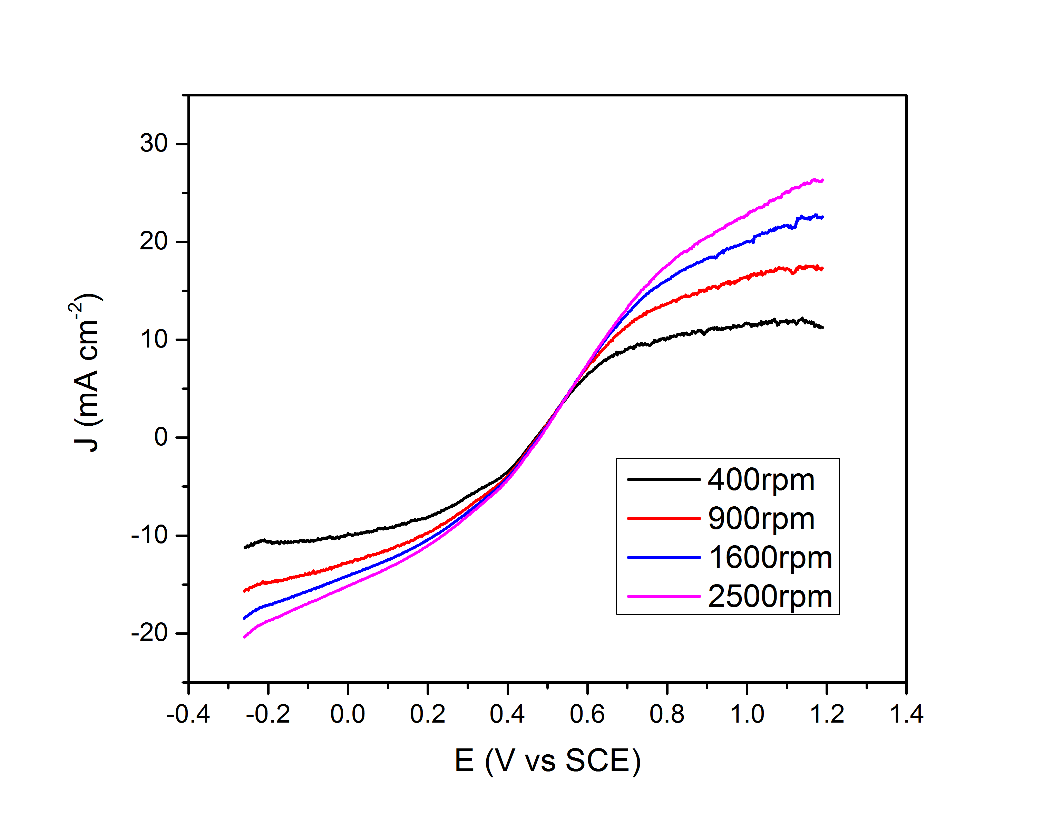
Figure 3: PRR with 20% Pt/C

The steep slopes in Figure 2 and Figure 3 represent the reduction of oxygen and peroxide, respectively, based on different rotation speeds of the working electrode. By rotating the electrode, a flow pattern is created that enhances the reaction. These figures are very similar to what was found by Katsounaros et al. with ORR and PRR with a Pt disk, which suggests the 20% Pt/C was an effective catalyst as well.
Participating in this research has been a phenomenal learning experience. Learning the field of electrochemistry through literature and the graduate students at Trinity College Dublin was a great opportunity for me to take my learning experience into my own hands. I learned how to ask for help and clarification in ways I never have before, and I was also exposed to what a graduate school experience may be like. This experience will help me in further lab courses at Albion College and beyond that, since I plan to pursue a chemistry-related career. I hope to continue working on this research in Fall of 2019 by testing Pt₂₀₀A900 CMs and Pt₁₀₀A900 CMs as electrochemical catalysts for ORR and PRR. I also hope to turn this experience into an honors thesis as well as present it at Elkin Isaac and an ACS conference. Overall, this experience taught me not to give up when things did not go as planned. Instead, I learned to look at the issue at large to determine what may have happened. Problem solving is an essential skill to have in any career path, and this experience taught me to persevere and keep working hard when problems arise. This will help me to be successful in my future career, which I am extremely thankful for. I would like to thank the Richard K. Vitek,'56 FURSCA Endowment for funding this unforgettable experience that has taught me so much not just about chemistry, but about myself. It has been a privilege to participate in research in my field of interest.

Elgrishi, N.; Rountree, K. J.; McCarthy, B. D.; Rountree, E. S.; Eisenhart, T. T.; Dempsey, J. L. A Practical Beginner's Guide to Cyclic Voltammetry. Journal of Chemical Education 2017, 2018(95), 197–206.
Katsounaros, I.; Schneider, W. B.; Meier, J. C.; Benedikt, U.; Biedermann, P. U.; Auer, A. A.; Mayrhofer, K. J. Hydrogen Peroxide Electrochemistry on Platinum: towards Understanding the Oxygen Reduction Reaction Mechanism. PCCP2012, 2012(14), 7384–7391.
Domínguez, C.; Metz, K. M.; Hoque, M. K.; Browne, M. P.; Esteban-Tejeda, L.; Livingston, C. K.; Lian, S.; Perova, T. S.; Colavita, P. E. Continuous Flow Synthesis of Platinum Nanoparticles in Porous Carbon as Durable and Methanol-Tolerant Electrocatalysts for the Oxygen Reduction Reaction. ChemElectroChem2017, 5(1), 62–70.
Duffy, P.; Reynolds, L. A.; Sanders, S. E.; Metz, K. M.; Colavita, P. E. Materials Chemistry and Physics 2013, 140 (1), 343–349.

